REACT NATIVE


React Native is an React Native is an open-source mobile application framework developed by Meta (formerly Facebook). It enables developers to build truly native mobile applications for Android and iOS using a single JavaScript and React-based codebase. [1, 2, 3]
Unlike hybrid frameworks that render web pages inside a wrapper, React Native translates your code directly into native UI components. This gives applications the performance, look, and feel of an app built natively with Swift, Objective-C, Java, or Kotlin
⚙️ How React Native Works
React Native isolates the application logic from the user interface rendering by utilizing multiple threads: [1, 2]
- The JavaScript Thread: This is where the core business logic, API calls, and React components are processed. [1]
- The Main/Native UI Thread: This handles the actual rendering of the screen elements and processes user inputs like taps and gestures. [1, 2]
- The Architecture: Historically, these threads communicated asynchronously via a Bridge using JSON data. Modern iterations of the framework utilize the JavaScript Interface (JSI), allowing JavaScript to directly invoke native methods for much faster performance. [1]

React Native

Developers | Meta and community
Release | April 26, 2015; 11 years ago^{[1]}
Stable release | 0.87.1^{[2]} / 26 August 2026; 35 days ago
Written in | C++, Java, JavaScript, Objective-C, Kotlin
Platform | Android, Android TV, iOS, macOS, tvOS, OpenHarmony,Web, Windows, UWP, VR, Vega OS and visionOS
Type | Application framework
License | MIT License
Website | reactnative.dev
Repository | github.com/react/react-native

REACT NATIVE HISTORY

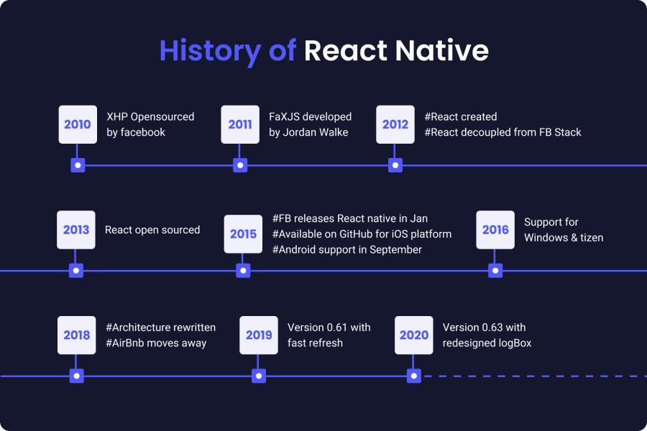
React Native History
1. Before React Native
- Before React Native, mobile applications were generally developed separately for different platforms.
- Android applications were commonly developed using:
  - Java
  - Later, Kotlin
  - Android SDK
- iOS applications were commonly developed using:
  - Objective-C
  - Later, Swift
  - iOS SDK
- Companies developing applications for both platforms often maintained separate codebases.
Android → Java / Kotlin
iOS → Objective-C / Swift

2. Beginning of React
- React Native is based on React, so its history starts with React.
- In 2011, Facebook engineers started working on ideas that eventually became React.
- Jordan Walke, a Facebook engineer, created an early prototype of React.
- React was designed around reusable and component-based user interfaces.
- In 2013, Facebook publicly introduced React.js.
React introduced concepts such as:
- Components
- JSX
- Props
- State
- Declarative UI
- Reusable UI

3. Idea of Using React for Mobile
- After React became successful for web development, Facebook engineers explored whether the React programming model could be used for mobile applications.
- The goal was to allow developers to use React and JavaScript concepts while building mobile applications.
- This work eventually led to the creation of React Native.
React
↓
JavaScript
↓
React Native
↓
Native Mobile UI

4. React Native Started at Facebook
- React Native started as an internal project at Facebook.
- Facebook engineers experimented with using JavaScript and React concepts for native mobile applications.
- Jordan Walke was one of the important engineers associated with the early development.
- The project gradually evolved into a framework for creating mobile applications.

5. React Native Announced — 2015
- React Native was publicly announced by Facebook in 2015.
- The initial public release focused on iOS.
- It allowed developers to use React concepts for building native mobile interfaces.
React Components
↓
React Native
↓
Native Mobile Components

6. React Native Became Open Source — 2015
- React Native was released as an open-source project in 2015.
- Developers outside Facebook could now:
  - Use React Native
  - Study the source code
  - Report issues
  - Contribute improvements
  - Create libraries
  - Build applications
- Open-source development helped React Native grow into a larger ecosystem.

7. Android Support — 2015
- React Native initially focused on iOS.
- Android support was introduced later in 2015.
- This allowed developers to use React Native for both major mobile platforms.
React Native
│
┌───────┴───────┐
↓ ↓
Android iOS

8. Original React Native Architecture
- Early React Native versions used a communication mechanism commonly called the Bridge.
- JavaScript code communicated with native platform code through the Bridge.
JavaScript
↓
Bridge
↓
Native Code
↓
Android / iOS
- This architecture allowed JavaScript to control native components and communicate with native functionality.

9. Growth of React Native Ecosystem
- After React Native became open source, its developer community grew.
- Developers created libraries and tools for common requirements.
Ecosystem areas included:
- Navigation
- Forms
- API integration
- Authentication
- State management
- Animations
- Local storage
- Maps
- Device APIs
- UI components

10. Expo
- Expo became an important part of the React Native ecosystem.
- It provides tools that simplify React Native development.
- Expo can help with:
  - Project creation
  - Development
  - Testing
  - Building applications
  - Accessing device features
  - Managing parts of the native workflow

11. React Native Community
- React Native originally came from Facebook.
- Over time, the wider open-source community became increasingly involved.
- In 2018, Facebook announced the React Native Community initiative.
- Community involvement helped maintain and improve many React Native libraries and tools.

12. React Native 0.60 — 2019
- React Native 0.60 was an important release.
- Major improvements included:
  - AndroidX support
  - Autolinking
  - CocoaPods improvements
  - Accessibility improvements
  - Native dependency improvements
Autolinking
- Autolinking made installing many native React Native libraries easier.
- Developers no longer needed to manually configure every native dependency.
Install Package
↓
React Native detects dependency
↓
Native dependency is linked

13. React Native 0.61 — 2019
- React Native 0.61 introduced Fast Refresh.
- Fast Refresh improved the development experience.
- Developers could see many code changes reflected quickly while developing.
Write Code
↓
Save
↓
Fast Refresh
↓
Updated Application

14. React Native 0.62 — 2020
- React Native 0.62 introduced improvements to the development experience.
- Flipper integration became an important debugging feature.
- Flipper provided tools for inspecting and debugging React Native applications.

15. Hermes
- Hermes is a JavaScript engine developed by Meta with React Native applications in mind.
- It is designed for efficient JavaScript execution on mobile devices.
Main goals:
- Faster startup
- Better memory efficiency
- Improved performance
- Efficient JavaScript execution
- Hermes became an important part of modern React Native development.

16. Limitations of the Old Architecture
- The original architecture relied heavily on the Bridge.
- As applications became larger and more complex, the architecture presented areas that needed improvement.
Areas that required improvement:
- JavaScript-to-native communication
- Performance
- Native module interaction
- Rendering
- Startup performance
- Support for modern React capabilities
- React Native therefore began developing a New Architecture.

17. New Architecture
- React Native introduced the New Architecture to modernize the framework.
- Important technologies include:
  - JSI
  - Fabric
  - TurboModules
  - Bridgeless Mode

18. JSI
- JSI stands for JavaScript Interface.
- It provides an interface that allows JavaScript to interact more directly with native/C++ functionality.
- JSI is an important foundation of the New Architecture.
Old Architecture

JavaScript
↓
Bridge
↓
Native

New Architecture

JavaScript
↓
JSI
↓
Native / C++

19. Fabric
- Fabric is React Native's newer rendering system.
- It modernizes how React Native renders user interfaces.
Main purposes:
- Improve rendering
- Improve responsiveness
- Support modern React capabilities
- Provide a modern foundation for React Native UI

20. TurboModules
- TurboModules are part of React Native's New Architecture.
- They provide a newer approach for communicating with native modules.
Main purposes:
- Improve native module performance
- Improve module loading
- Provide a modern native-module system

21. Bridgeless Mode
- Bridgeless Mode is part of the New Architecture.
- Its goal is to remove dependence on the traditional Bridge.
Old Architecture

JavaScript
↓
Bridge
↓
Native

New Architecture

JavaScript
↓
JSI
↓
Native

22. React Native 0.68 — 2022
- React Native 0.68 was an important milestone for the New Architecture.
- The New Architecture became available as an opt-in feature.
- Developers could experiment with:
  - Fabric
  - TurboModules
  - JSI
- The old architecture was still available.

23. React Native 0.69 — 2022
- React Native 0.69 introduced support for React 18.
- This allowed React Native to continue adopting newer React capabilities.
React
↓
React Native
↓
Android / iOS

24. React Native 0.70 — 2022
- React Native 0.70 continued improvements to:
  - Hermes
  - New Architecture
  - Android
  - iOS
  - Developer experience
- Hermes became increasingly important in React Native development.

25. React Native 0.71 — 2023
- React Native 0.71 introduced several improvements.
- An important area was improved TypeScript support.
React Native
+
TypeScript
- TypeScript became increasingly common for modern React Native applications.

26. React Native 0.72 — 2023
- React Native 0.72 continued improvements to:
  - Metro
  - New Architecture
  - Developer experience
  - JavaScript tooling
  - Performance

27. React Native 0.73 — 2023
- React Native 0.73 continued the modernization of the framework.
- Improvements were made to:
  - Android
  - iOS
  - TypeScript
  - JavaScript tooling
  - New Architecture
  - Build systems

28. React Native 0.74 — 2024
- React Native 0.74 continued the transition toward the New Architecture.
- Bridgeless Mode became available as part of this architectural work.
- React Native continued moving away from dependence on the traditional Bridge.
Old Architecture
↓
Bridge
↓
Native

New Architecture
↓
JSI + Fabric + TurboModules
↓
Native

29. React Native 0.76 — 2024
- React Native 0.76 was a major milestone.
- The New Architecture became enabled by default for new React Native applications.
- Important technologies include:
  - Fabric
  - TurboModules
  - JSI
  - Bridgeless capabilities
- This marked a major stage in the transition from the old architecture to the New Architecture.

30. React Native 2025–2026
- React Native continued receiving regular releases and improvements.
- Development continued around:
  - New Architecture
  - React compatibility
  - TypeScript
  - Hermes
  - Android
  - iOS
  - Performance
  - Developer experience
  - Accessibility
  - Native integration
- React Native has developed into a mature open-source mobile development framework.

React Native History Timeline
Year | Major Event
2011 | Early React work began at Facebook
2013 | React.js publicly introduced
2013–2014 | React concepts explored for mobile development
2015 | React Native publicly announced
2015 | React Native open-sourced
2015 | Android support added
2016–2018 | React Native ecosystem expanded
2018 | React Native Community initiative
2019 | React Native 0.60 — AndroidX and Autolinking
2019 | React Native 0.61 — Fast Refresh
2020 | React Native 0.62 — Flipper integration
2021 | Hermes and platform improvements continued
2022 | New Architecture became available as opt-in
2022 | React 18 support
2023 | New Architecture and TypeScript improvements
2024 | Bridgeless Mode and New Architecture improvements
2024 | React Native 0.76 — New Architecture enabled by default for new apps
2025–2026 | Continued development and modernization

Quick Revision
- 2011 → Early React development
- 2013 → React.js introduced publicly
- 2015 → React Native announced
- 2015 → React Native became open source
- 2015 → Android support added
- 2019 → AndroidX + Autolinking
- 2019 → Fast Refresh
- 2020 → Flipper integration
- 2022 → New Architecture introduced as opt-in
- 2022 → React 18 support
- 2024 → New Architecture enabled by default for new apps
- 2025–2026 → Continued development of modern React Native
Important Technologies
React Native
│
├── JavaScript / TypeScript
├── React
├── Hermes
├── JSI
├── Fabric
├── TurboModules
├── Bridgeless Mode
├── Android
└── iOS

WHAT IS REACT NATIVE

-React Native is an open-source framework developed by Meta (Facebook) that allows developers to build mobile applications for Android and iOS using JavaScript and React.
In simple words:
-React Native lets you use React and JavaScript to create mobile apps that run on Android and iOS.
WHAT IS REACT NATIVE?
1. Definition
- React Native is an open-source framework used to develop mobile applications.
- It was developed by Facebook (now Meta).
- It is mainly used to build applications for:
  - Android
  - iOS
- React Native allows developers to use JavaScript or TypeScript along with the React programming model.

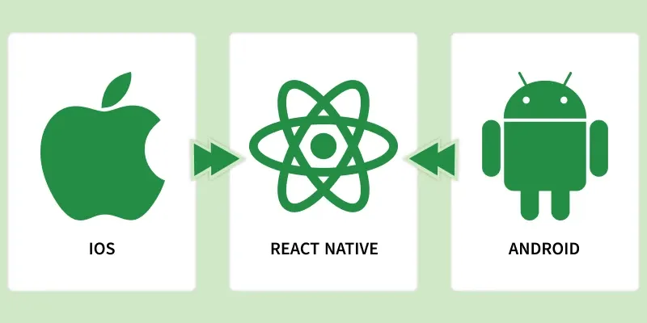

Simple Example
Normally, mobile apps can be developed using:
- Android → Java / Kotlin
- iOS → Swift / Objective-C
With React Native, you can use:
- JavaScript
- React
- JSX
- React Native components
to build applications for both Android and iOS.

2. Meaning of React Native
The name React Native consists of two parts:
React
- React provides the programming model used to create the user interface.
- It uses concepts such as:
  - Components
  - Props
  - State
  - Hooks
  - JSX
  - Reusable UI
Native
- Native refers to the mobile platform's native capabilities and UI.
- React Native allows applications to interact with native Android and iOS functionality.
React
+
Native
↓
React Native

3. What React Native Is Used For
- React Native is used to develop mobile applications.
- It can be used to create applications for both Android and iOS.
- Developers can share a significant amount of application code between the two platforms.
React Native
│
┌─────────┴─────────┐
↓ ↓
Android iOS

4. Technology Used in React Native
React Native development commonly involves:
- JavaScript
- TypeScript
- React
- JSX / TSX
- React Native components
- Native APIs
JavaScript / TypeScript
↓
React
↓
React Native
↓
Android / iOS

5. React Native Is Different From React.js
- React.js is primarily used for web development.
- React Native is used for mobile application development.
React.js | React Native
Web applications | Mobile applications
Runs in a browser | Runs on mobile platforms
Uses HTML elements | Uses React Native components
Uses browser DOM | Uses native mobile platform functionality
<div> | <View>
<p> | <Text>
<img> | <Image>
CSS | React Native styling

6. React Native Components
React Native provides components that are used to create mobile user interfaces.
Common Components
- View → Container for UI elements
- Text → Displays text
- Image → Displays images
- TextInput → Accepts user input
- Button → Creates a basic button
- Pressable → Handles press interactions
- ScrollView → Creates scrollable content
- FlatList → Displays lists efficiently
Example:
<View>
<Text>Hello React Native</Text>
</View>

7. React Concepts in React Native
React Native uses many concepts that are also used in React.js.
Components
- Applications are divided into reusable components.
Props
- Props are used to pass data from one component to another.
State
- State stores data that can change during application execution.
Hooks
React Native supports React hooks such as:
- useState()
- useEffect()
- useContext()
- useReducer()
- useMemo()
- useCallback()
- useRef()

8. JSX in React Native
- React Native commonly uses JSX.
- JSX allows developers to describe the UI inside JavaScript.
Example:
const App = () => {
return (
<View>
<Text>Welcome to React Native</Text>
</View>
);
};
- JSX makes component structure easier to understand and maintain.

9. Styling in React Native
- React Native uses JavaScript/TypeScript-based styling.
- It does not use HTML and CSS exactly like React.js.
- StyleSheet is commonly used to define styles.
Example:
const styles = StyleSheet.create({
container: {
flex: 1,
justifyContent: "center",
alignItems: "center",
},
});
- Styles can also be applied directly using the style prop.
<View style={styles.container}>
<Text>Hello</Text>
</View>

10. Cross-Platform Development
- React Native supports cross-platform mobile development.
- The same project can contain code that works on both Android and iOS.
React Native
│
Shared Application Code
│
┌───────┴───────┐
↓ ↓
Android iOS
- A significant portion of application code can be shared.
- Platform-specific code can still be written when required.

11. Native Functionality
- React Native applications can access native device features.
- Examples include:
  - Camera
  - GPS / Location
  - Notifications
  - Bluetooth
  - Device storage
  - Sensors
  - Contacts
  - Files
  - Native platform APIs
- When a feature requires platform-specific functionality, React Native can work with native Android or iOS code.

12. React Native Architecture
A simplified development flow is:
JavaScript / TypeScript
↓
React
↓
React Native
↓
Native Platform
↙ ↘
Android iOS
- Developers write application logic using JavaScript or TypeScript.
- React manages components and application UI.
- React Native connects the React application with mobile platform functionality.

13. Advantages of React Native
Cross-Platform
- A significant amount of code can be shared between Android and iOS.
React Knowledge
- Developers who already know React.js can reuse many React concepts.
Reusable Components
- Components can be created once and reused throughout the application.
JavaScript / TypeScript
- Developers can use JavaScript or TypeScript.
Large Ecosystem
- React Native has a large ecosystem of libraries and tools.
Native Access
- Applications can access native mobile functionality.
Fast Development
- Development features such as Fast Refresh help developers see changes quickly.

14. Limitations of React Native
- Not every part of an application can always be completely shared between Android and iOS.
- Some features require platform-specific implementation.
- Native dependencies can sometimes require additional configuration.
- Developers may need knowledge of Android or iOS development for advanced requirements.
- Third-party libraries may have compatibility or maintenance issues.

15. Applications That Can Be Built
React Native can be used to create:
- E-commerce applications
- Fitness applications
- Education applications
- Social media applications
- Food delivery applications
- Booking applications
- Banking and business applications
- Service applications
- Productivity applications
- Internal company applications

16. Simple Example
A simple React Native application can look like:
import { View, Text } from "react-native";

const App = () => {
return (
<View>
<Text>Hello React Native</Text>
</View>
);
};

export default App;
Explanation
- View → creates a container.
- Text → displays text.
- App → is a React component.
- JSX → describes the UI.
- React Native → renders the application for the target mobile platform.

17. React Native in Simple Words
JavaScript / TypeScript
+
React
+
React Native
↓
Mobile Application
↓
┌──────┴──────┐
↓ ↓
Android iOS
- JavaScript / TypeScript → used to write application logic.
- React → provides the component-based programming model.
- React Native → provides the mobile development framework.
- Android / iOS → are the target mobile platforms.

18. Key Points to Remember
- React Native is a framework.
- Developed by Facebook (Meta).
- Used for mobile application development.
- Supports Android and iOS.
- Uses React concepts.
- Supports JavaScript and TypeScript.
- Uses JSX / TSX.
- Uses reusable components.
- Provides components such as:
  - View
  - Text
  - Image
  - TextInput
  - Button
  - Pressable
  - ScrollView
  - FlatList
- Supports access to native device features.
- Allows significant code sharing between Android and iOS.
- Modern React Native uses the New Architecture.
- Important New Architecture technologies include:
  - JSI
  - Fabric
  - TurboModules
  - Bridgeless Mode
- Hermes is a JavaScript engine commonly used with React Native.

19. Interview Definition
React Native is an open-source cross-platform framework developed by Meta that allows developers to build mobile applications for Android and iOS using React, JavaScript, or TypeScript.

WHY REACT NATIVE?

-Traditionally developing an IOS app require app knowledge of swift or objective c where as building android app requires the Java or Kotlin expertise.
-Consider the with approximately 31% on IOS and 68% on Android you would typically need to develop to separate apps using different technologies.
-However you are familiar with React Native you can create apps that works on the both platforms.
-React Native is I high demand in the Job Market
-Rather than assembling separate team of iOS and android developers’ businesses can optional for a single team proficient React Native, that saving time and costs.
-If the team is well-versed in React their expertise can extend to web app development as well.
-Finally the company like Microsoft, Tesla, Meta ,discord ,Pinterest uses the React Native for building the Mobile apps.

WORKING OF REACT NATIVE

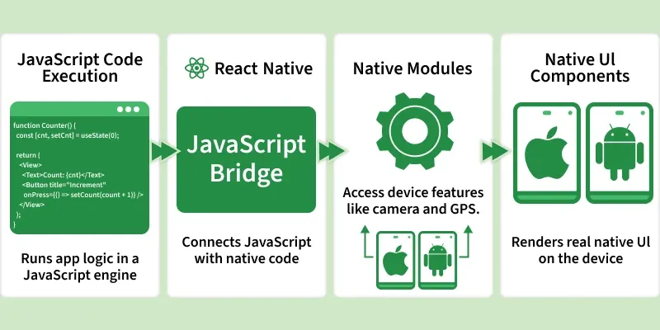
-React Native works by allowing developers to write application logic and UI using JavaScript/TypeScript and React, while React Native connects that code with the native capabilities of Android and iOS.

1. Developer Writes React Native Code
- The developer writes application code using JavaScript or TypeScript.
- React concepts such as:
  - Components
  - Props
  - State
  - Hooks
  - JSX/TSX
- are used to build the application.
Example:
import { View, Text } from "react-native";

const App = () => {
return (
<View>
<Text>Hello React Native</Text>
</View>
);
};

export default App;
- Here:
  - View represents a container.
  - Text displays text.
  - JSX describes what the UI should look like.

2. React Creates a Component Tree
- React reads the components and creates a component tree.
- For example:
App
└── View
└── Text
- React keeps track of the component structure and its state.
- When state or props change, React determines what part of the UI needs to be updated.

3. React Native Provides Native Components
- React Native provides components such as:
View
Text
Image
TextInput
ScrollView
Pressable
FlatList
- These are not normal HTML elements.
- React Native maps these components to the corresponding native platform functionality.
For example:
<View>
<Text>Hello</Text>
</View>
conceptually becomes:
View → Native mobile view/container
Text → Native text component

4. JavaScript/TypeScript Code Runs
- The application logic is written in JavaScript or TypeScript.
- This code handles things such as:
- User interactions
- State management
- API calls
- Data processing
- Navigation
- Form handling
Business logic
- React Native provides the environment required for this JavaScript/TypeScript code to interact with the mobile application.

5. React Native Connects JavaScript With Native Code
- A mobile application needs access to platform-specific functionality.
- Examples include:
Camera
GPS
Bluetooth
Notifications
File system
Sensors
Contacts
Storage
- React Native provides APIs and native modules that allow JavaScript/TypeScript code to interact with these platform capabilities.

6. Android and iOS Have Native Implementations
- React Native ultimately works with the native platforms.
React Native
↓
Android / iOS
- Android uses its native Android environment.
- iOS uses its native iOS environment.
- Therefore, React Native applications can use platform-specific functionality when required.

7. Simplified Working Flow
The overall working can be understood as:
Developer
↓
JavaScript / TypeScript
↓
React Components
↓
React Native
↓
Native Platform APIs
↓
Android / iOS
↓
Mobile Application UI

8. Example of the Working
Suppose we create a button:
<Pressable onPress={handlePress}>
<Text>Click Me</Text>
</Pressable>
The process can be understood as:
User writes Pressable component
↓
React Native understands the component
↓
React manages the component/state
↓
React Native connects it with native functionality
↓
Native mobile UI handles the interaction
↓
User taps the button
↓
JavaScript function is executed

9. Working When User Interacts With the App
Suppose the user presses a button that changes a counter.
const [count, setCount] = useState(0);

<Pressable onPress={() => setCount(count + 1)}>
<Text>{count}</Text>
</Pressable>
The flow is:
User presses button
↓
Press event occurs
↓
Event handler runs
↓
setCount() updates state
↓
React detects state change
↓
React calculates required UI update
↓
React Native updates the required native UI
↓
Updated value appears on screen

10. React Reconciliation
- React uses a process called reconciliation to determine what needs to change when props or state are updated.
- React compares the previous component representation with the new one.
- It identifies the required changes.
- React Native then applies the necessary updates to the native UI.
Example:
Before:
Count: 0
After clicking:
Count: 1
- React does not need to recreate the entire application.
- It identifies that the displayed value needs to change.

11. JavaScript Thread and Native Side
A simplified view of traditional React Native architecture can be represented as:
JavaScript
│
│
React Logic
│
↓
React Native
│
│
Bridge
│
↓
Native Code
/ \
Android iOS
- JavaScript handles application logic.
- Native code handles platform-specific functionality.
- Historically, the Bridge was used for communication between JavaScript and native code.

12. React Native New Architecture
Modern React Native uses the New Architecture, which modernizes communication between JavaScript and native code.
Important technologies include:
JSI
Fabric
TurboModules
Bridgeless Mode
JSI — JavaScript Interface
- JSI provides an interface between JavaScript and native/C++ code.
- It enables more direct interaction between JavaScript and native functionality.
- It is an important part of the modern React Native architecture.
Fabric
- Fabric is React Native's modern rendering system.
- It handles rendering and updates of React Native components.
TurboModules
- TurboModules are the modern system for accessing native modules.
- They improve how JavaScript interacts with native functionality.
Bridgeless Mode
- Modern React Native can operate without the traditional Bridge.
- This reduces dependence on the older Bridge-based architecture.

13. Role of Hermes
- Hermes is a JavaScript engine optimized for React Native applications.
- It executes JavaScript code on the device.
- It is designed to improve application startup and runtime characteristics.
Simplified flow:
JavaScript / TypeScript
↓
Hermes
↓
React Native
↓
Native Platform

14. Working With API Calls
React Native applications can communicate with backend APIs.
Example:
React Native App
↓
fetch / Axios
↓
Backend API
↓
Database
↓
API Response
↓
React Native App
↓
UI Update
For example:
const response = await fetch("https://example.com/users");
const data = await response.json();
- The application sends a request.
- The backend processes the request.
- Data is returned.
- React state can be updated.
- The UI displays the received data.

15. Working With Platform-Specific Code
- Most application code can be shared between Android and iOS.
- However, some features require platform-specific implementation.
Example:
Shared React Native Code
↓
┌──────┴──────┐
↓ ↓
Android-specific iOS-specific
code code
- React Native provides platform-specific APIs and patterns when Android and iOS need different behavior.

16. Complete React Native Working
The complete simplified process is:
Developer writes
JavaScript / TypeScript
↓
React Components
↓
JSX / TSX
↓
React processes components
↓
React Native rendering system
↓
Native platform interaction
↓
Android / iOS
↓
Mobile UI
↓
User interaction
↓
Events / State changes
↓
React updates the UI

17. Simple Real-Life Example
Suppose you create a login screen:
Login Screen
↓
TextInput
↓
User enters email/password
↓
Presses Login
↓
JavaScript function executes
↓
API request is sent
↓
Server validates credentials
↓
Response received
↓
React state is updated
↓
UI changes
↓
User sees result
React Native manages the React-based application layer while providing access to the native mobile platform.

18. React Native Working in One Line
JavaScript / TypeScript
↓
React
↓
React Native
↓
Native Android / iOS functionality
↓
Mobile Application

19. Important Points to Remember
- React Native uses React to build mobile application interfaces.
- Applications can be written using JavaScript or TypeScript.
- JSX/TSX is used to describe the UI.
- React manages components, props, state, and rendering logic.
- React Native provides mobile-specific components and APIs.
- React Native connects the React layer with Android and iOS functionality.
- User interactions generate events.
- State changes can cause React to update the UI.
- React Native supports significant code sharing between Android and iOS.
- Platform-specific code can be used when necessary.
- Modern React Native uses the New Architecture.
- Important New Architecture technologies include JSI, Fabric, TurboModules, and Bridgeless Mode.
- Hermes is a JavaScript engine used with React Native applications.

Interview Definition
React Native works by using React and JavaScript/TypeScript to describe application logic and UI, then connecting that React-based code with native Android and iOS functionality to create mobile applications.

FEATURES OF REACT NATIVE

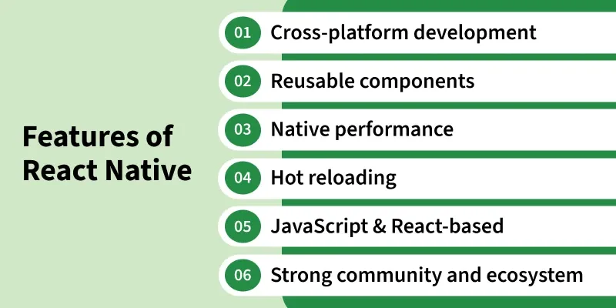
React Native provides features that make it possible to build mobile applications for Android and iOS using React, JavaScript, or TypeScript.

1. Cross-Platform Development
- React Native allows developers to build applications for Android and iOS.
- A large portion of the application code can be shared between both platforms.
- This reduces the need to build the complete application separately for Android and iOS.
React Native Code
↓
┌─────────┴─────────┐
↓ ↓
Android iOS

2. Uses JavaScript and TypeScript
- React Native applications can be developed using:
  - JavaScript
  - TypeScript
- Developers familiar with JavaScript can use their existing programming knowledge.
- TypeScript can provide static typing and improved developer tooling.
Example:
const App = () => {
return <Text>Hello React Native</Text>;
};

3. React-Based Development
- React Native is based on the React programming model.
- Developers can use React concepts such as:
  - Components
  - Props
  - State
  - Hooks
  - Context
  - Component composition
Example:
const Welcome = ({ name }) => {
return <Text>Hello {name}</Text>;
};

4. Reusable Components
- React Native encourages developers to create reusable components.
- A component can be created once and used in multiple places.
Example:
const CustomButton = () => {
return (
<Pressable>
<Text>Submit</Text>
</Pressable>
);
};
The same component can be reused:
Login Screen
↓
CustomButton

Register Screen
↓
CustomButton

Profile Screen
↓
CustomButton

5. Native Platform Integration
- React Native can interact with native Android and iOS functionality.
- Applications can use platform capabilities such as:
  - Camera
  - Location
  - Notifications
  - Bluetooth
  - Sensors
  - Storage
  - Files
  - Contacts
- When a feature requires native functionality, React Native can communicate with native platform code.

6. Native User Interface
- React Native provides components that map to native platform functionality.
- Common components include:
- View
- Text
- Image
- TextInput
- Pressable
- ScrollView
- FlatList
- This allows applications to use mobile-oriented UI components instead of HTML elements.

7. Fast Refresh
- Fast Refresh helps developers see code changes quickly during development.
- When code is modified, the application can update the relevant UI without requiring a complete manual restart in many cases.
- It makes the development and debugging process faster.
Example:
Change Code
↓
Save File
↓
Fast Refresh
↓
Updated UI

8. Hot Reloading / Fast Development Feedback
- React Native development provides rapid feedback while developing the application.
- Modern React Native primarily uses Fast Refresh for this purpose.
- Developers can quickly see changes made to components and styles.

9. Component-Based Architecture
- React Native applications are built using components.
- Each component can represent a part of the user interface.
Example:
App
├── Header
├── Navigation
├── ProductList
│ ├── ProductCard
│ ├── ProductCard
│ └── ProductCard
└── Footer
- This makes applications easier to organize and maintain.

10. JSX / TSX Support
- React Native uses JSX with JavaScript and TSX with TypeScript.
- JSX/TSX allows developers to describe UI directly inside JavaScript/TypeScript code.
Example:
const App = () => {
return (
<View>
<Text>Welcome</Text>
</View>
);
};

11. State Management
- React Native supports React's state management features.
- The useState Hook is commonly used for local component state.
Example:
const [count, setCount] = useState(0);
- When state changes, React can update the corresponding UI.

12. Hooks Support
React Native applications can use React Hooks such as:
- useState
- useEffect
- useContext
- useReducer
- useMemo
- useCallback
- useRef
Example:
useEffect(() => {
console.log("Component loaded");
}, []);
- Hooks make it easier to manage state, side effects, references, and other React functionality.

13. Efficient List Rendering
React Native provides components specifically designed for lists.
FlatList
- Used for efficiently rendering lists of data.
SectionList
- Used for lists divided into sections.
Example:
FlatList
↓
Large / Dynamic List
↓
Efficient Item Rendering

14. Platform-Specific Development
- Although React Native allows code sharing, Android and iOS sometimes require different implementations.
- React Native provides platform-specific APIs and mechanisms for handling these differences.
Example:
import { Platform } from "react-native";

if (Platform.OS === "android") {
// Android-specific code
}
Possible platform values include:
android
ios

15. Native Modules
- React Native allows JavaScript/TypeScript code to interact with native functionality through native modules.
- Native modules can provide functionality that is not directly available through JavaScript alone.
Example areas:
- Camera
- Bluetooth
- Location
- Storage
- Sensors
- Device APIs
- Modern React Native uses TurboModules as part of its New Architecture for native modules.

16. New Architecture
Modern React Native includes a New Architecture designed to improve how React Native communicates with and renders native functionality.
Important technologies include:
JSI
Fabric
TurboModules
Bridgeless Mode
JSI
- JavaScript Interface.
- Provides a lower-level interface for communication between JavaScript and native/C++ code.
Fabric
- React Native's modern rendering system.
- Handles rendering and updates of React Native components.
TurboModules
- Modern approach for native modules.
- Improves the interaction between JavaScript and native functionality.
Bridgeless Mode
- Allows React Native to operate without depending on the traditional Bridge architecture.

17. Hermes JavaScript Engine
- React Native can use Hermes, a JavaScript engine optimized for React Native.
- Hermes executes JavaScript code in the application.
- It is designed with React Native mobile applications in mind.
Simplified flow:
JavaScript
↓
Hermes
↓
React Native
↓
Android / iOS

18. API Integration
- React Native applications can communicate with backend APIs.
- Developers can use tools such as:
  - fetch
  - Axios
  - Other HTTP libraries
Example:
const response = await fetch(
"https://example.com/users"
);

const data = await response.json();
The application can then use the received data to update the UI.
React Native App
↓
API Request
↓
Backend
↓
Database
↓
API Response
↓
React Native UI

19. Styling Support
- React Native provides a JavaScript-based styling system.
- The style prop is used to apply styles to components.
- StyleSheet can be used to organize styles.
Example:
import { StyleSheet, Text } from "react-native";

<Text style={styles.title}>
Hello React Native
</Text>

const styles = StyleSheet.create({
title: {
fontSize: 24,
fontWeight: "bold",
},
});
- React Native styling is similar to CSS in many concepts, but it is not normal browser CSS.

20. Accessibility Support
- React Native provides accessibility properties that help make mobile applications usable by people with disabilities.
- Developers can provide information to assistive technologies such as screen readers.
Example:
<Pressable
accessible={true}
accessibilityLabel="Submit form"
>
<Text>Submit</Text>
</Pressable>

21. Debugging and Developer Tools
- React Native provides development and debugging capabilities.
- Developers can inspect application behavior and troubleshoot issues.
- React Developer Tools and platform-specific debugging tools can be used depending on the development setup.

22. Large Ecosystem
- React Native has a large ecosystem of:
  - Libraries
  - Packages
  - Tools
  - Community projects
  - Native integrations
- Developers can use existing libraries instead of implementing every feature from scratch.

23. Open Source
- React Native is an open-source framework.
- Its source code is publicly available.
- Developers and contributors can inspect the project and contribute to its development.

24. Code Sharing
- A significant amount of application logic and UI code can be shared between Android and iOS.
For example:
- Authentication
- API Calls
- State Management
- Business Logic
- Reusable Components
- Validation
can often be shared.
However, platform-specific code may still be required for some features.

25. Integration With Existing Native Applications
- React Native can be introduced into an existing native Android or iOS application.
- This makes it possible to gradually add React Native screens or features rather than necessarily rebuilding an entire application from scratch.

FEATURES AT A GLANCE
Feature | Purpose
Cross-platform | Build Android and iOS applications
JavaScript / TypeScript | Application development languages
React | Component-based UI development
Reusable Components | Reuse UI and logic
Native Integration | Access device/platform capabilities
Core Components | Build mobile UI
Fast Refresh | Quickly see development changes
JSX / TSX | Describe UI
Hooks | Manage state and React behavior
FlatList | Efficient list rendering
Platform APIs | Handle Android/iOS differences
Native Modules | Access native functionality
New Architecture | Modern rendering and native integration
Hermes | JavaScript engine
API Integration | Connect with backend services
Styling | Design mobile interfaces
Accessibility | Support accessible applications
Open Source | Publicly developed framework
Ecosystem | Libraries and community tools
Code Sharing | Share code across platforms

KEY POINTS TO REMEMBER
- React Native supports Android and iOS development.
- It uses React with JavaScript or TypeScript.
- It follows a component-based development model.
- It provides reusable Core Components.
- It supports native platform integration.
- It allows significant code sharing between platforms.
- Fast Refresh improves development workflow.
- JSX/TSX is used to describe UI.
- React Hooks can be used for state and component behavior.
- FlatList and SectionList support efficient list rendering.
- Platform-specific APIs allow Android and iOS differences to be handled.
- The New Architecture includes JSI, Fabric, TurboModules, and Bridgeless Mode.
- React Native can use the Hermes JavaScript engine.
- It supports API integration, styling, accessibility, debugging, and native modules.
- React Native is open source and has a large ecosystem.

Interview Definition
React Native is a cross-platform, open-source framework that uses React, JavaScript, or TypeScript to build mobile applications for Android and iOS, while providing reusable components and access to native platform functionality.

WHO IS USING REACT NATIVE?

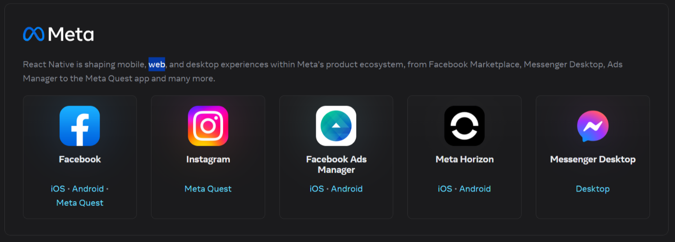
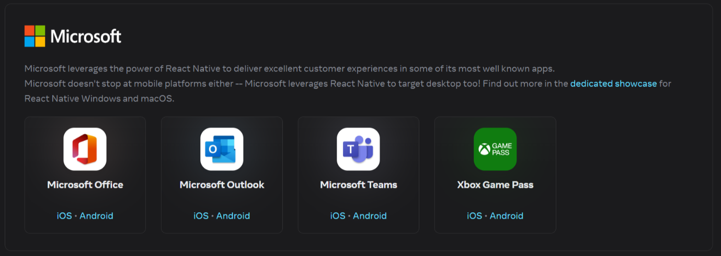
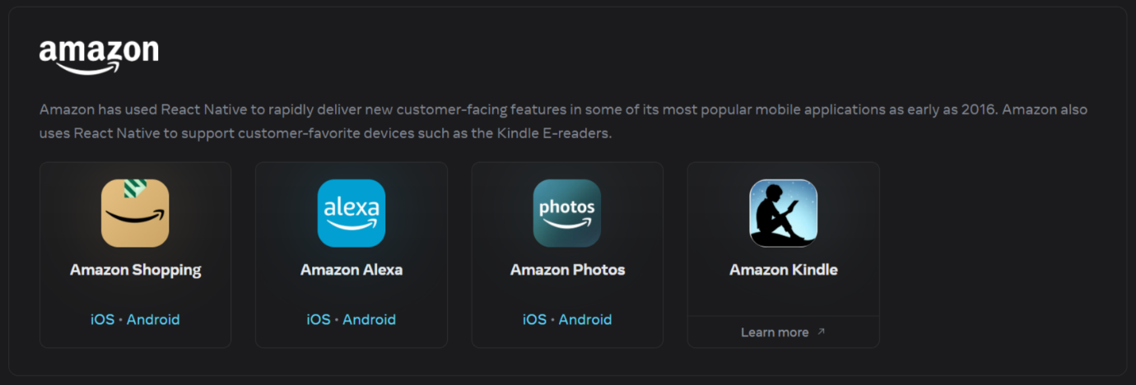
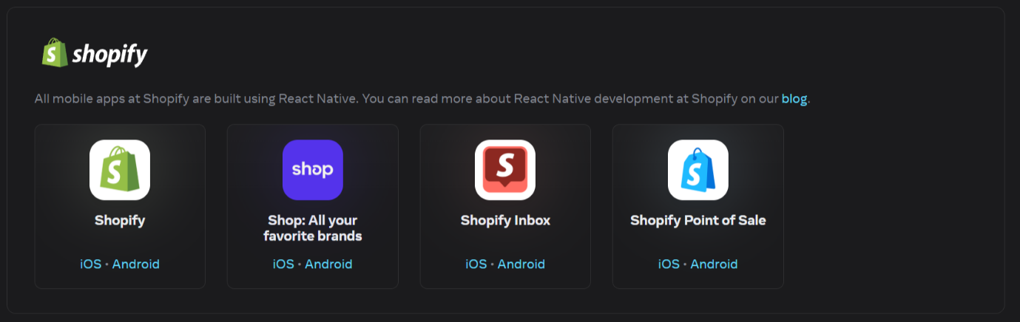
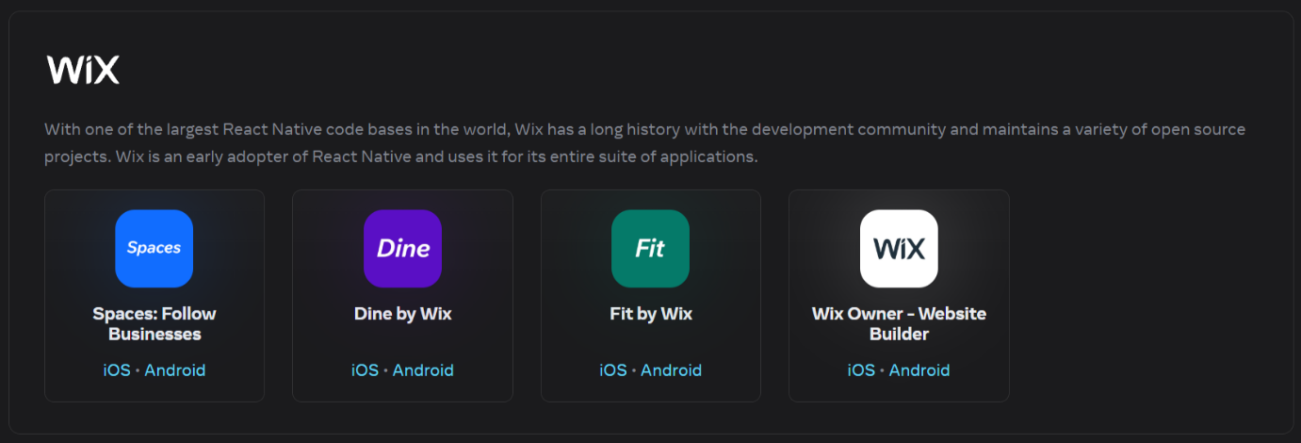
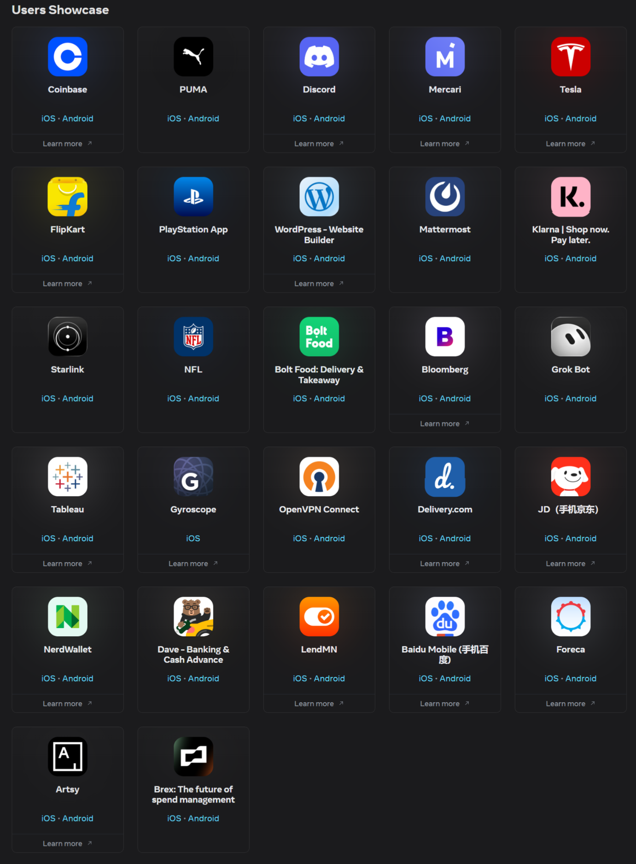

WHAT IS EXPO
- Expo is a framework and development platform built around React Native.
- It provides tools and services that make it easier to create, develop, test, and build React Native applications.
- Expo simplifies many parts of React Native development, especially the initial project setup and development workflow.
- It allows developers to start a React Native project without manually configuring every native development component at the beginning.
- Expo provides a collection of libraries and APIs for common mobile features such as:
  - Camera
  - Notifications
  - Location
  - Sensors
  - File system
  - Device information
- Expo projects can be created using:
npx create-expo-app@latest MyReactNativeApp
- After creating the project, the development server can be started using:
npx expo start
- Expo supports development for Android and iOS, and can also support web development.
- Expo provides development tools that help developers test applications during development.
- Expo is particularly useful for beginners because it reduces the amount of initial native configuration required.
- Expo does not replace React Native. Instead, it provides a development platform and tools built around React Native.
In Simple Words
Expo is a platform and set of tools that makes React Native application development easier, faster, and simpler.

EXPO VS REACT NATIVE

- React Native is the framework used to build cross-platform mobile applications using JavaScript/TypeScript and React.
- Expo is a framework and development platform built on top of React Native that provides additional tools, libraries, and services.
- Therefore, Expo and React Native are not completely separate technologies.
- Expo uses React Native underneath.
1. React Native
- React Native is an open-source framework for building mobile applications.
- It allows developers to create applications for Android and iOS using React.
- It provides direct access to native Android and iOS project configuration.
- Developers can use native Android/iOS code when required.
- The React Native Community CLI can be used to create a project.
npx @react-native-community/cli@latest init MyReactNativeApp

2. Expo
- Expo is a framework and development platform built around React Native.
- It simplifies React Native development.
- It provides additional libraries and development tools.
- It provides APIs for common device features.
- Expo has q suite of tools and services built around React Native, which is greatly simplifies the development process.
- With the plain React Native , you cannot build the IIOS apps on a windows or Linux machine. native IOS apps can only be built on a macOS machine.
- With Expo you can develop your app on windows or Linux run your app on a physical iPhone.
- Expo has evolved significantly over the year and now supports nearly all the features necessary for building mobile apps.
- In the event that you require access to native Android or IOS code, Expo allows you to eject your app and work with the plain React Native Codebase.
- Project creation is simpler:
npx create-expo-app@latest MyReactNativeApp

3. Main Differences
Feature | React Native | Expo
Type | Mobile app framework | Framework/platform built around React Native
Based on | React | React Native
Android | ✅ | ✅
iOS | ✅ | ✅
Project Setup | More configuration | Simpler
Native Configuration | Direct control | Simplified
Native Code | Directly supported | Supported, with Expo workflows/tools
Device APIs | Can use libraries/native modules | Provides many ready-to-use APIs
Beginner Friendly | Moderate | ✅ Very beginner friendly
Development Tools | Core tooling | Additional Expo tooling
CLI | Community CLI | Expo CLI/tools
Project Creation | npx @react-native-community/cli... | npx create-expo-app...

4. Project Creation
React Native Community CLI
npx @react-native-community/cli@latest init MyReactNativeApp
- Creates a React Native project.
- Provides direct native project configuration.
- You manage more of the native development environment yourself.
Expo
npx create-expo-app@latest MyReactNativeApp
- Creates an Expo-based React Native project.
- Provides a simpler development experience.
- Many common features can be added using Expo's libraries and APIs.

5. Relationship Between Expo and React Native
The relationship can be represented as:
React Native
↓
Core Mobile Framework
↓
Expo
↓
Additional Tools + APIs +
Development Services
A more accurate way to understand it is:
React
↓
React Native
↓
Expo
├── Development Tools
├── APIs
├── Libraries
└── Build / Deployment Services
- React Native provides the core framework for building native mobile applications.
- Expo builds on React Native and provides additional tooling and services.

6. When to Use React Native Community CLI
- When you need direct access to native Android/iOS projects.
- When you need extensive native customization.
- When your project requires custom native modules.
- When you want more direct control over the native build configuration.

7. When to Use Expo
- When you are learning React Native.
- When you want a simpler project setup.
- When you want ready-to-use APIs for common device features.
- When you want Expo's development and build tooling.
- When your application does not require extensive custom native configuration.

INSATALLATION OF REACT NATIVE

WAYS TO CREATE A REACT NATIVE APP
A React Native application can be created using different CLI-based approaches. The modern approach is to use npx instead of installing the React Native CLI globally.

1. Using Expo

- Expo is a framework and development platform built around React Native.
- It provides a simplified way to create and develop React Native applications.
- It is beginner-friendly and requires less initial native configuration.

Command
npx create-expo-app@latest MyReactNativeApp
Steps
- Open Command Prompt / Terminal.
- Navigate to the folder where you want to create the project.
- Run:
npx create-expo-app@latest MyReactNativeApp
- Move into the project:
cd MyReactNativeApp
- Start the development server:
npx expo start
Explanation
- npx → Executes an npm package without requiring a permanent global installation.
- create-expo-app → Tool used to create an Expo application.
- @latest → Uses the latest version of the package.
- MyReactNativeApp → Name of the application.
Move into the Project
cd MyReactNativeApp
Start the Development Server
npx expo start
Expo Templates

-Expo provides templates for creating projects with different starting configurations.
- Default Expo
npx create-expo-app@latest MyReactNativeApp
- Creates an Expo application using the default template.
- Provides a ready-to-start Expo project.
- Blank Expo
npx create-expo-app@latest MyReactNativeApp --template blank
- Creates a more minimal Expo project.
- Contains less pre-configured application code.
- Useful when you want to build the project structure yourself.
- Blank TypeScript
npx create-expo-app@latest MyReactNativeApp --template blank-typescript
- Creates a minimal Expo project using TypeScript.
- Useful when you want TypeScript from the beginning.
METHODS OF EXPOS

Method 1: npx create-expo-app app-name --template
npx create-expo-app app-name --template

Note: Replace the app-name with your app name for example : react-native-demo-app
Select the blank template to generate a minimal React Native project setup.
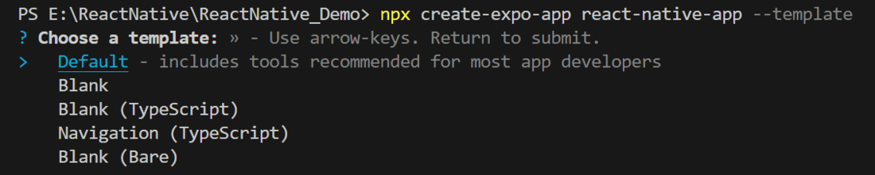
- Method 2: Using create-expo-app
npx create-expo-app@latest project-name
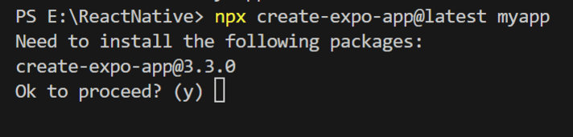
Result of Method 1 and Method 2:
It completes the project creation and displays a message: "Your Project is ready!" as shown in the image below.
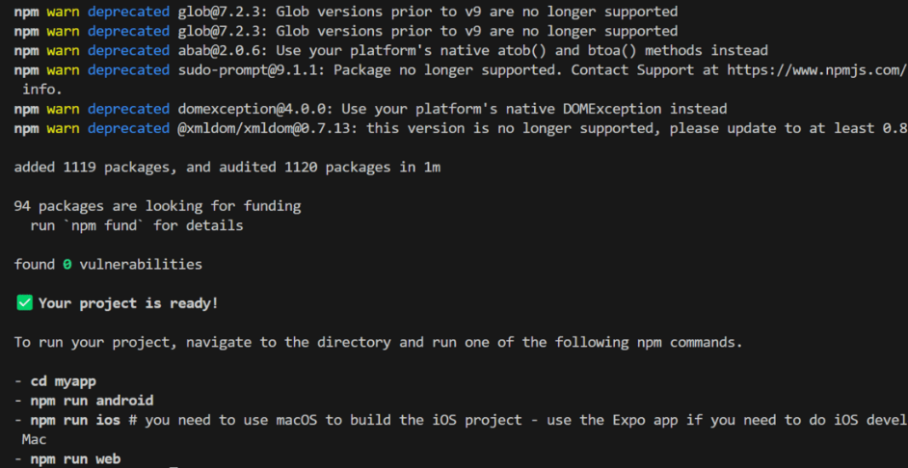
Go into the created folder and start the server by using the following command.
cd "project-name"
Step 2: Reset-Project (Only for Method 2)
Reset the project to the default boilerplate by running the command below.
npm run reset-project
- The CLI prompts to preserve existing project files.
- Selecting y moves the current boilerplate to the /app-example directory.
- This operation performs a file relocation, not deletion, ensuring code safety.
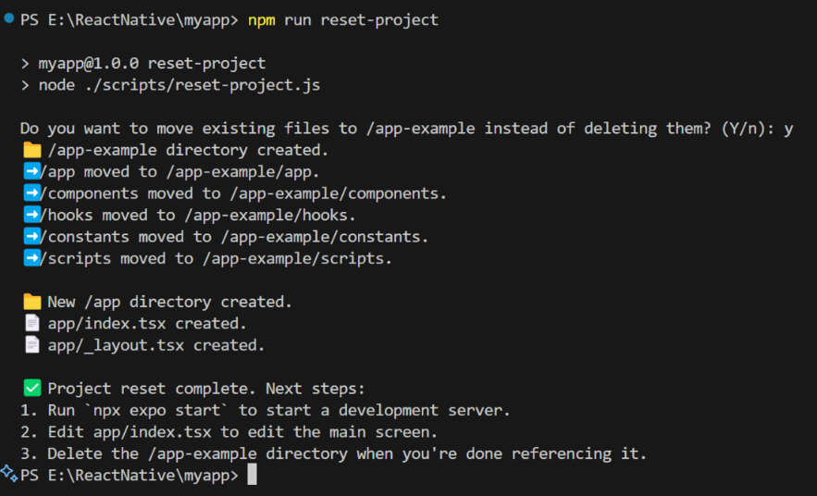
Step 3: Run the app
To start the react-native program, execute this command in the terminal of the project folder.
npx expo start
Then, the application will display a QR code.
- Android: Install Expo Go from the Play Store, open the app, tap Scan QR Code, and scan the QR to run the app on your device.
- iOS: Scan the QR code directly using the Camera app to launch the app.
- Web: A localhost URL is provided to run the app in the browser.
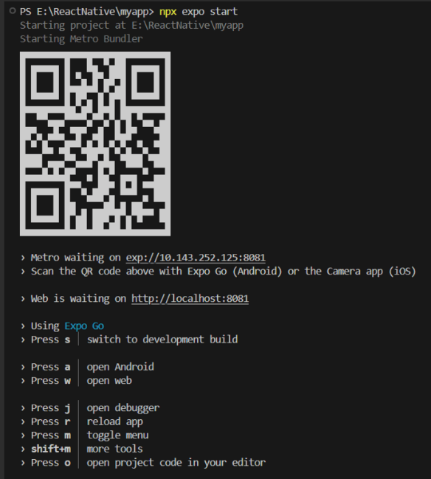
Output of Method 1:
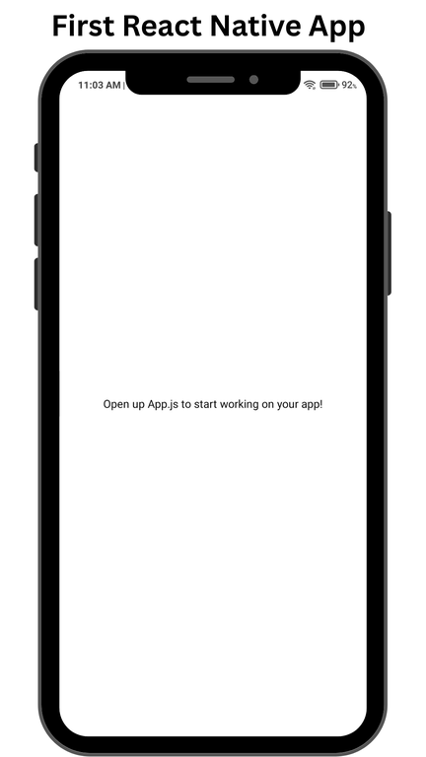
Output of Method 2:
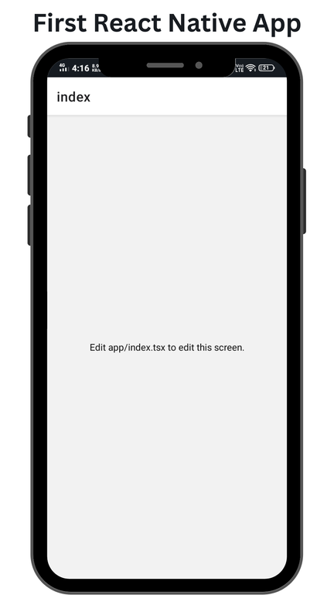
Example: We will render a text and put some style on the text, like text color and background color.
App.js | App/index.tsx:
import { Text, View, StyleSheet } from "react-native";

export default function Index() {
return (
<View style={styles.container}>
<Text style={styles.text}>GeeksforGeeks</Text>
</View>
);
}

const styles = StyleSheet.create({
container: {
flex: 1,
backgroundColor: '#008000',
alignItems: 'center',
justifyContent: 'center',
},
text: {
color: '#FFFFFF',
},
});
Note: Whether you are using method 1 or method 2, you can use above code.
Output of Method 1:
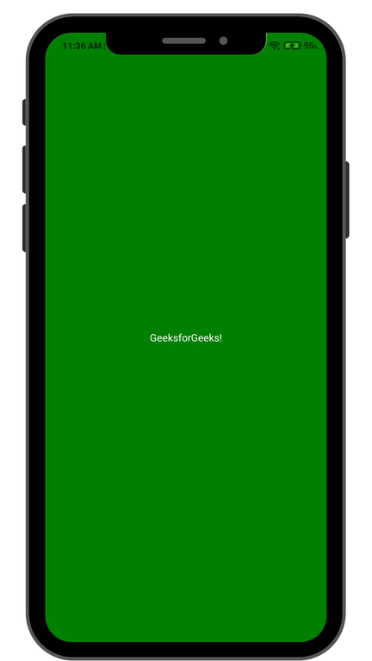
Output of Method 2:
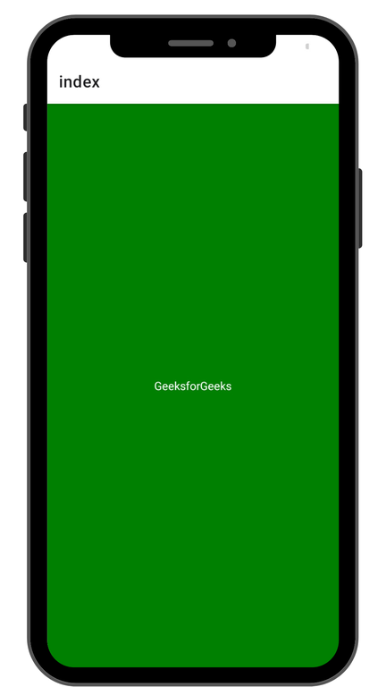

Important Points
- Expo does not require installing an Expo CLI globally.
- npx runs the required package when needed.
- Expo provides tools for developing and testing React Native applications.
- It is a good choice for beginners and many standard React Native applications.
- Expo provides a simplified development environment for React Native.
- It is suitable for beginners and for applications that can use Expo's development tools.

2. Using React Native Community CLI

- The React Native Community CLI provides a more direct React Native project setup.
- It gives you direct access to native Android and iOS project files.
- It is useful when you need greater control over native configuration.
- For Android development, Android Studio, Android SDK, JDK, and an emulator or physical device are commonly required.

Command
npx @react-native-community/cli@latest init MyReactNativeApp
Steps
- Open Command Prompt / Terminal.
- Navigate to your desired development folder.
- Run:
npx @react-native-community/cli@latest init MyReactNativeApp
- Move into the project:
cd MyReactNativeApp
- Start Metro:
npm start
- Open another terminal and run the Android application:
npm run android

Explanation
- npx → Executes the CLI without installing it globally.
- @react-native-community/cli → React Native Community CLI package.
- @latest → Uses the latest version.
- init → Creates a new React Native project.
- MyReactNativeApp → Name of the application.
Move into the Project
cd MyReactNativeApp
Start Metro
npm start
Run on Android
Open another terminal:
npm run android
Important Points
- The project contains native Android configuration.
- Android Studio and Android SDK are important for Android development.
- You have greater control over native Android configuration.
- It is useful for developers who need custom native functionality.
3. Global Installation

-Older tutorials may contain commands such as:
npm install -g create-react-native-app
or:
npm install -g react-native-cli
- These commands represent older tooling/workflows.
- They should not be used as the standard modern React Native setup.
- Modern React Native project creation uses npx.
Avoid
npm install -g react-native-cli
npm install -g create-react-native-app
Use Instead
Expo:
npx create-expo-app@latest MyReactNativeApp
Community CLI:
npx @react-native-community/cli@latest init MyReactNativeApp
Important
- This is the old global CLI approach.
- It should not be used for modern React Native project creation.
- You should avoid installing react-native-cli globally.
Do Not Use
npm install -g react-native-cli
Instead, use:
npx @react-native-community/cli@latest init MyReactNativeApp
Step 1: Install create-react-native-app
After installing NodeJS and NPM successfully in your system you can proceed with installation of create-react-native-app (globally as shown below).
C:\Users\Tutorialspoint> npm install -g create-react-native-app
Advertisement
Step 2: Create project
Browse through required folder and create a new react native project as shown below.
C:\Users\Tutorialspoint>cd Desktop
C:\Users\Tutorialspoint\Desktop>create-react-native-app MyReactNative
After executing the above command, a folder with specifies name is created with the following contents.
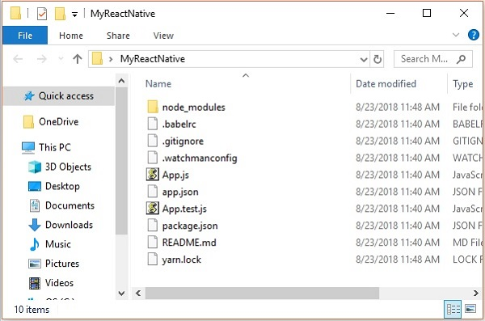
Step 3: NodeJS Python Jdk8
Make sure you have Python NodeJS and jdk8 installed in your system if not, install them. In addition to these it is recommended to install latest version of yarn to avoid certain issues.
Step 4: Install React Native CLI
You can install react native command line interface on npm, using the install -g react-native-cli command as shown below.
npm install -g react-native-cli
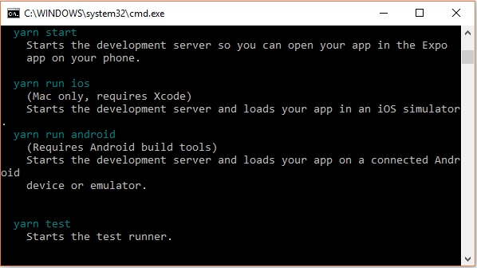
Step 5: Start react native
To verify the installation browse through the project folder and try starting the project using the start command.
C:\Users\Tutorialspoint\Desktop>cd MyReactNative
C:\Users\Tutorialspoint\Desktop\MyReactNative>npm start
If everything went well you will get a QR code as shown below.
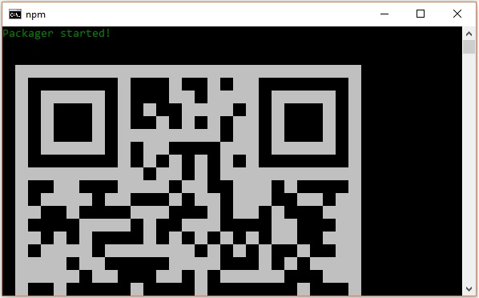
As instructed, one way to run react native apps on your android devise is to using expo. Install expo client in your android devise and scan the above obtained QR code.
Step 6: Eject the project
If you want to run android emulator using android studio, come out of the current command line by pressing ctrl+c.
Then, execute run eject command as
npm run eject
This prompts you options to eject, select the first one using arrows and press enter.
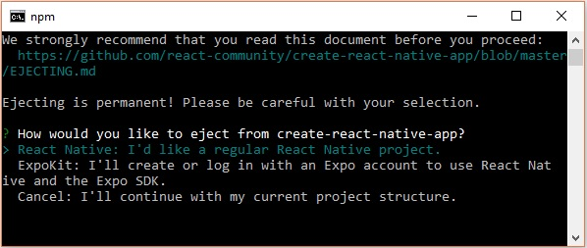
Then, you should suggest the name of the app on home screen and project name of the Android studio and Xcode projects.
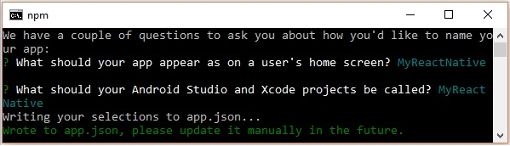
Though your project ejected successfully, you may get an error as −
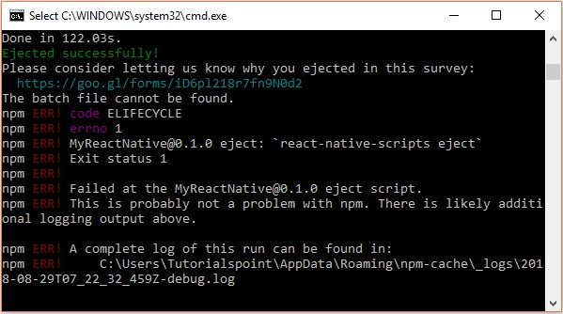
Ignore this error and run react native for android using the following command −
react-native run-android
But, before that you need to install android studio.
Step 7: Installing Android Studio
Visit the web page https://developer.android.com/studio/ and download android studio.
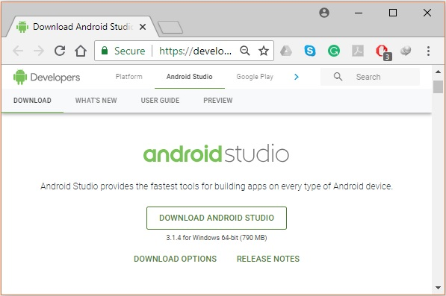
After downloading the installation file of it, double click on it and proceed with the installation.
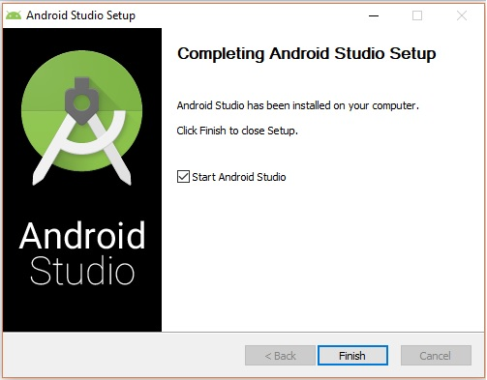
Step 8: Configuring AVD Manager
To configure the AVD Manager click on the respective icon in the menu bar.
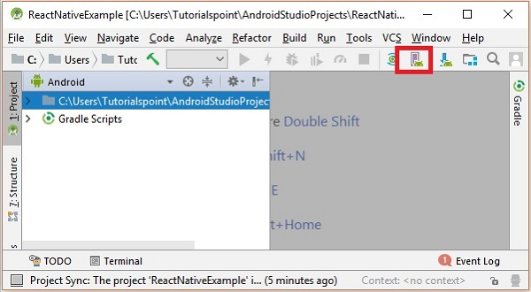
Step 9: Configuring AVD Manager
Choose a device definition, Nexus 5X is suggestable.
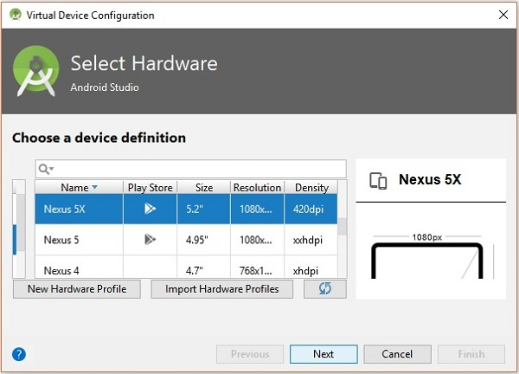
Click on the Next button you will see a System Image window. Select the x86 Images tab.
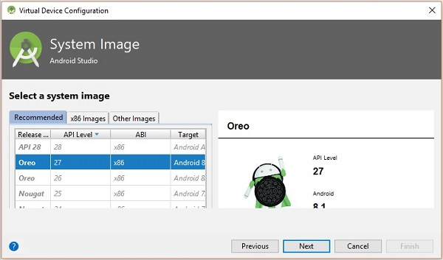
Then, select Marshmallow and click on next.
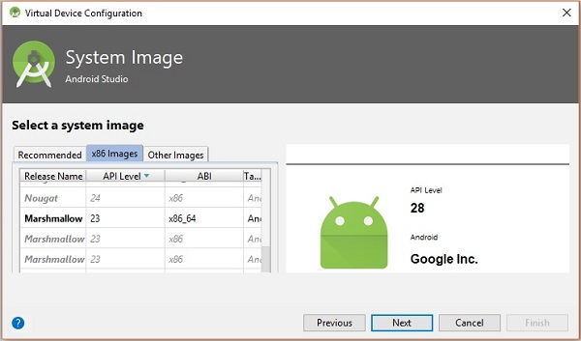
Finally, click on the Finish button to finish the AVD configuration.
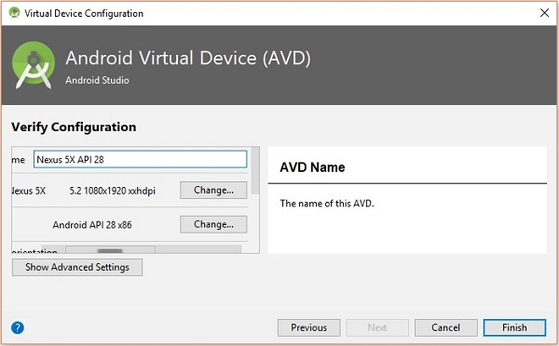
After configuring your virtual device click on the play button under the Actions column to start your android emulator.
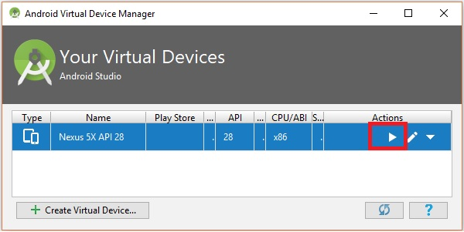
Step 10: Running android
Open command prompt, browse through your project folder and, execute the react-native run-android command.
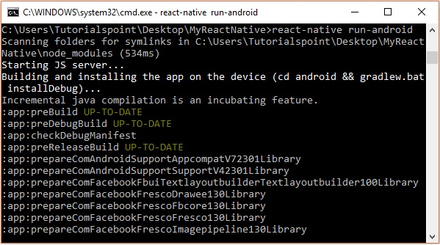
Then, your app execution begins in another prompt you can see its status.
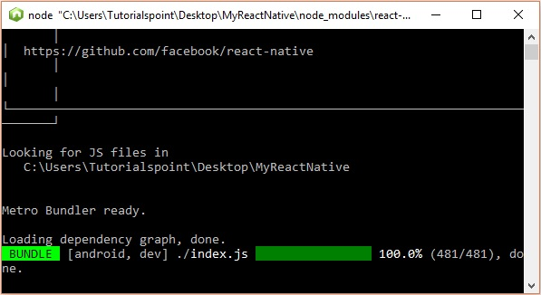
In your android emulator you can see the execution of the default app as −
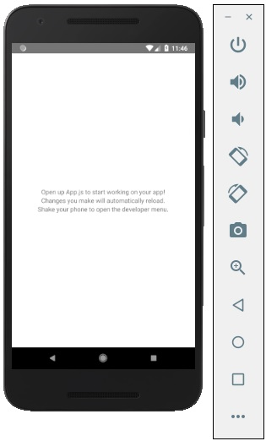
Step 11: local.properties
Open the android folder in your project folder SampleReactNative/android (in this case). Create a file with named local.properties and add the following path in it.
sdk.dir = /C:\\Users\\Tutorialspoint\\AppData\\Local\\Android\\Sdk
here, replace Tutorialspoint with your user name.
Step 12: Hot Reloading
And to build application modify the App.js and the changes will be automatically updated on the android emulator.
If not, click on the android emulator press ctrl+m then, select Enable Hot Reloading option.
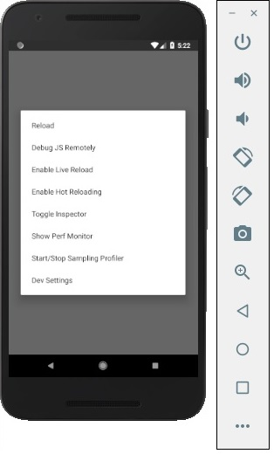

What Does npx Mean?
- npx is a tool that comes with modern npm.
- It allows you to execute npm packages without permanently installing their CLI globally.
- It is useful for project creation commands.
For example:
npx create-expo-app@latest MyReactNativeApp
Here:
- npx → Executes an npm package.
- create-expo-app → Expo's project creation tool.
- @latest → Uses the latest available version.
- MyReactNativeApp → Name of your application.

Global Installation vs npx
Method | Example | Status
Global React Native CLI | npm install -g react-native-cli | ❌ Old / Avoid
Expo with npx | npx create-expo-app@latest MyApp | ✅ Modern
Community CLI with npx | npx @react-native-community/cli@latest init MyApp | ✅ Modern

Recommended Commands
Expo
npx create-expo-app@latest MyReactNativeApp
React Native Community CLI
npx @react-native-community/cli@latest init MyReactNativeApp
Avoid Global CLI
npm install -g react-native-cli

Important Points
- Node.js is required for the React Native development tools.
- npm is installed along with Node.js.
- Expo provides a simplified React Native development workflow.
- Community CLI provides more direct native project control.
- Modern project creation uses npx.
- You generally do not need to install react-native-cli globally.
- create-react-native-app should not be used as the standard command in modern React Native notes.
- The application name can be changed from MyReactNativeApp to your preferred project name.

Complete Command Flow

Expo
Install Node.js
↓
Install npm (comes with Node.js)
↓
npx create-expo-app@latest MyReactNativeApp
↓
cd MyReactNativeApp
↓
npx expo start
↓
Run the application
React Native Community CLI
Install Node.js
↓
Install JDK
↓
Install Android Studio
↓
Configure Android SDK
↓
npx @react-native-community/cli@latest init MyReactNativeApp
↓
cd MyReactNativeApp
↓
npm start
↓
npm run android
↓
Run on Android Emulator / Device

SET UP AN ANDROID EMULATOR WITH EXPO GO
Set up Android Studio
macOS
Windows
1.Download Android Studio.
2.Open Android Studio Setup. Under Select components to install, select Android Studio and Android Virtual Device. Then, click Next.
3.In the Android Studio Setup Wizard, under Install Type, select Standard and click Next.

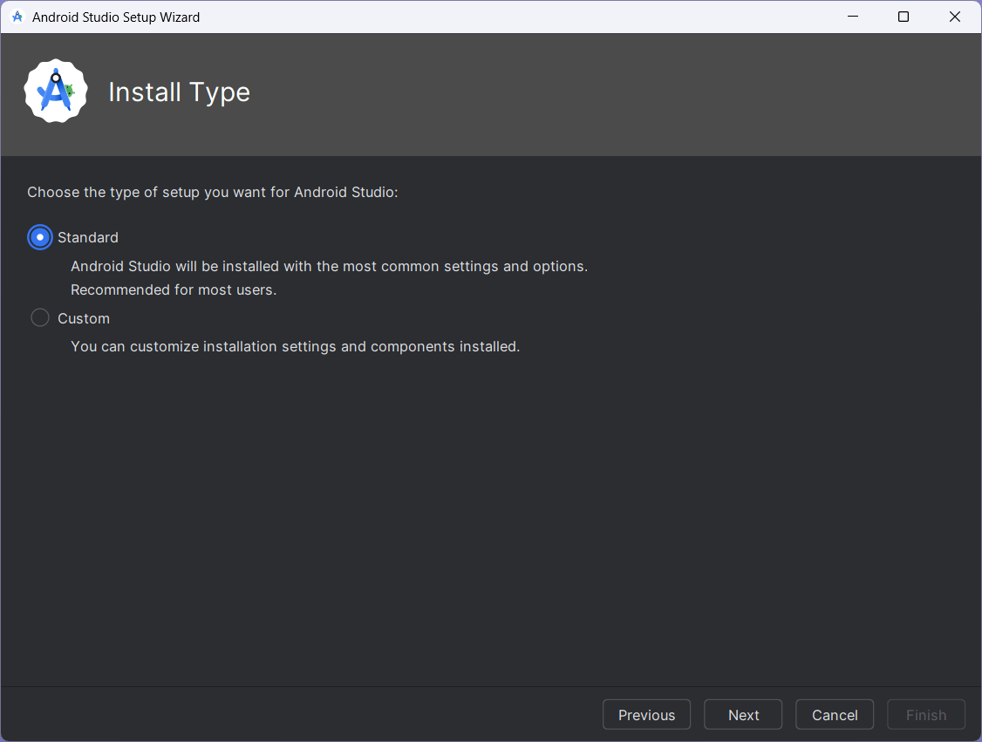
4.The Android Studio Setup Wizard will ask you to verify the settings, such as the version of Android SDK, platform-tools, and so on. Click Next after you have verified.
5.In the next window, accept licenses for all available components.
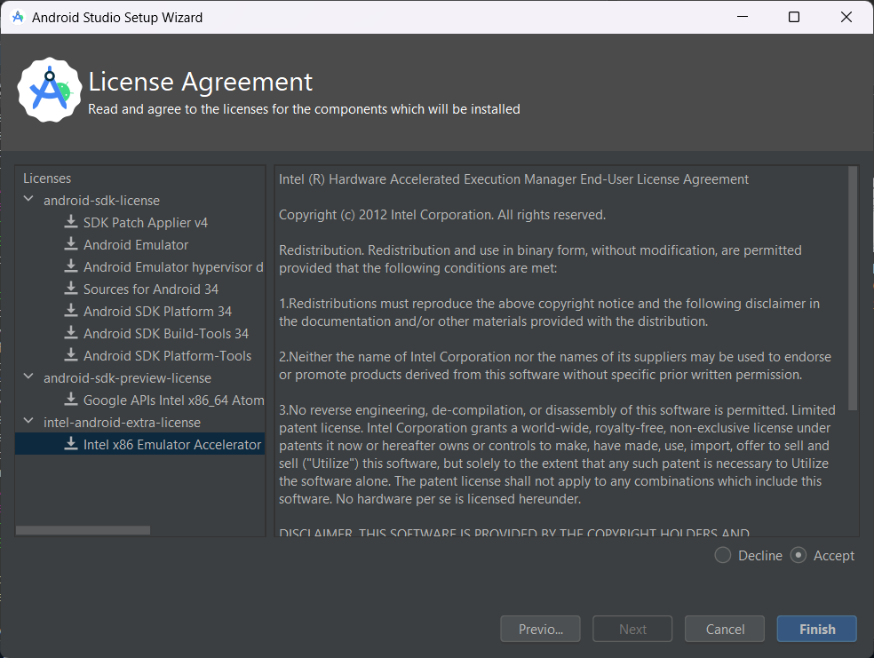
6.By default, Android Studio will install the latest version of the Android SDK. However, Android 16 (Baklava) SDK is required to compile a React Native app.
Open Android Studio, go to Settings > Languages & Frameworks > Android SDK. From the SDK Platforms tab, and under Android 16 (Baklava), select Android SDK Platform 36 and Sources for Android 36.
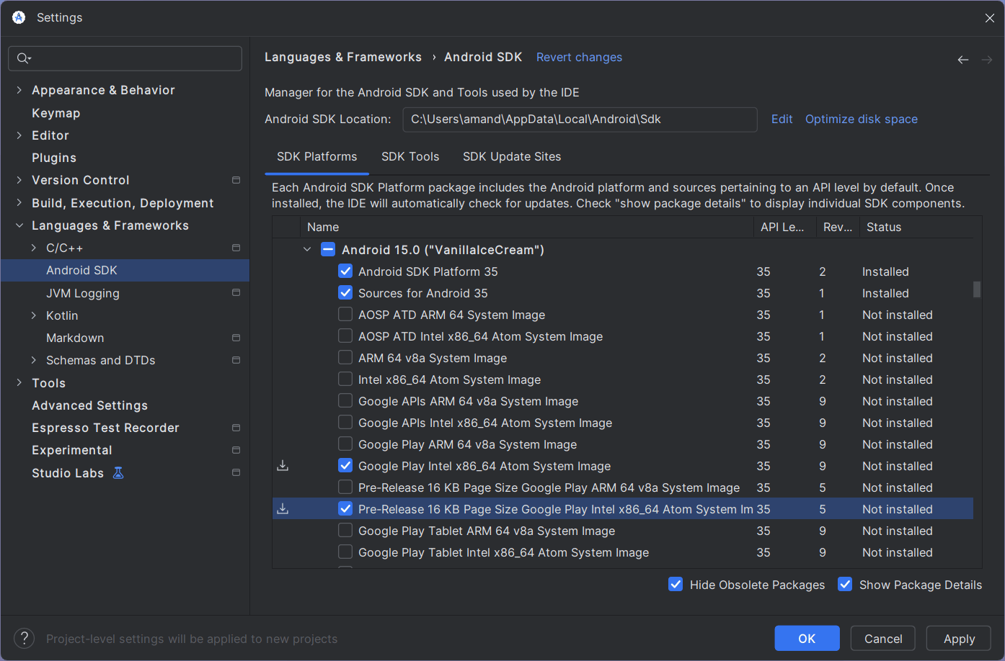
7.Then, click on the SDK Tools tab and make sure you have at least one version of the Android SDK Build-Tools and Android Emulator installed.
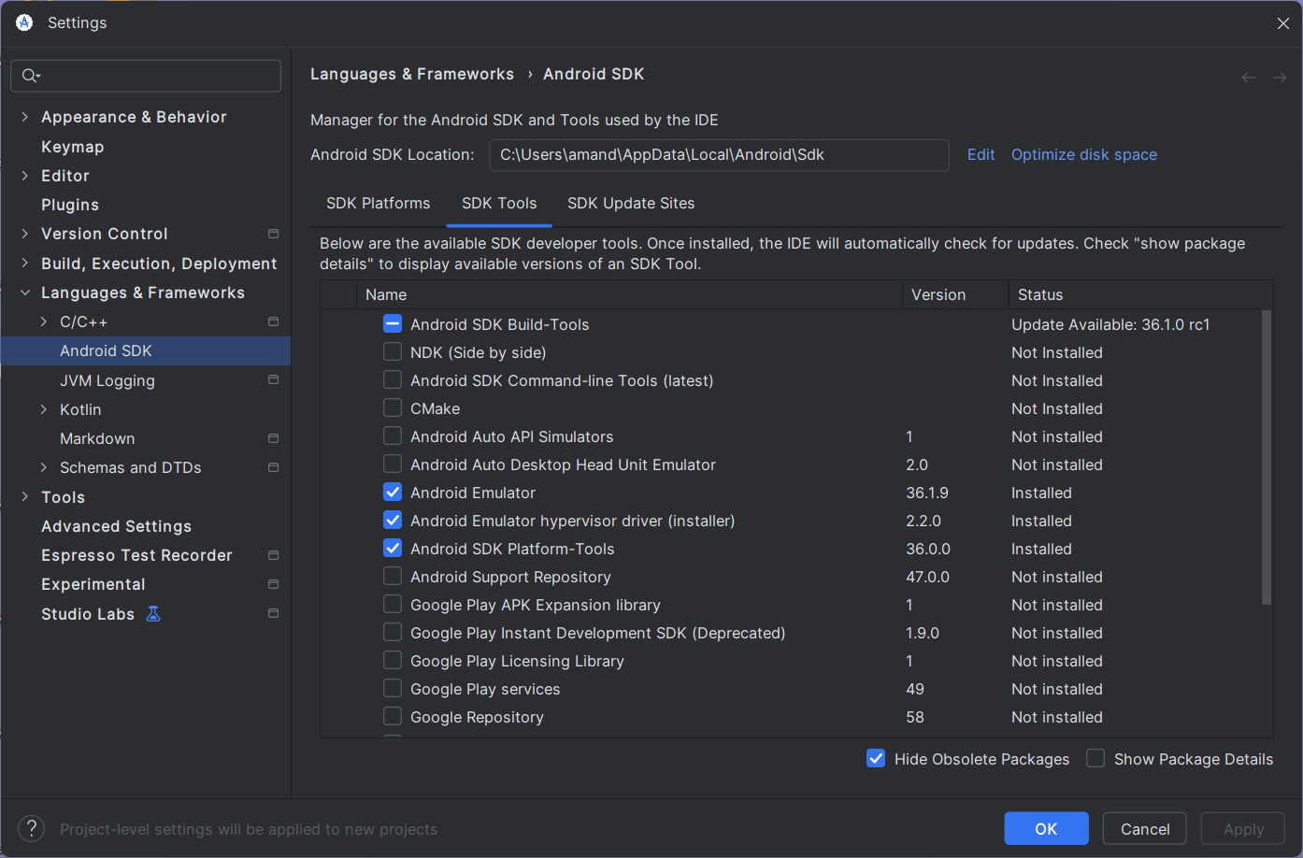
8.After the tools installation is complete, configure the ANDROID_HOME environment variable. Go to Windows Control Panel > User Accounts > User Accounts (again) > Change my environment variables and click New to create a new ANDROID_HOME user variable. The value of this variable will point to the path to your Android SDK:
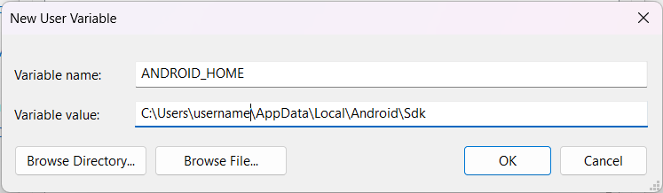
How to find installed SDK location?
By default, the Android SDK is installed at the following location:
%LOCALAPPDATA%\Android\Sdk
To find the location of the SDK in Android Studio manually, go to Settings > Languages & Frameworks > Android SDK. See the location next to Android SDK Location.
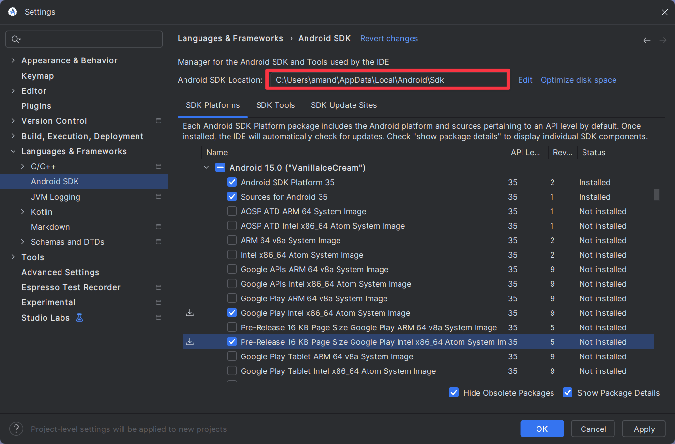
9.To verify that the new environment variable is loaded, open PowerShell, and copy and paste the following command:
Terminal
Copy
Get-ChildItem -Path Env:
The command will output all user environment variables. In this list, see if ANDROID_HOME has been added.
10
To add platform-tools to the Path, go to Windows Control Panel > User Accounts > User Accounts (again) > Change my environment variables > Path > Edit > New and add the path to the platform-tools to the list as shown below:
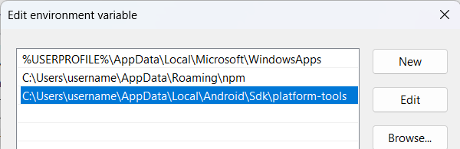
How to find installed platform-tools location
By default, the platform-tools are installed at the following location:
%LOCALAPPDATA%\Android\Sdk\platform-tools
11
Finally, make sure that you can run adb from the PowerShell. For example, run the adb --version to see which version of the adb your system is running.

Set up an emulator
1.On the Android Studio main screen, click More Actions, then Virtual Device Manager in the dropdown.
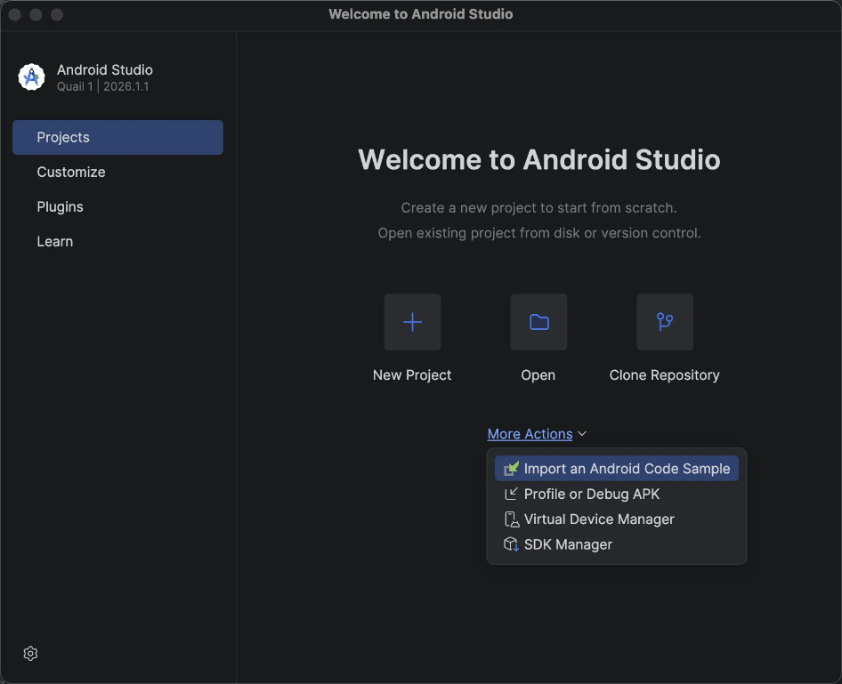
2.Click Create virtual device.
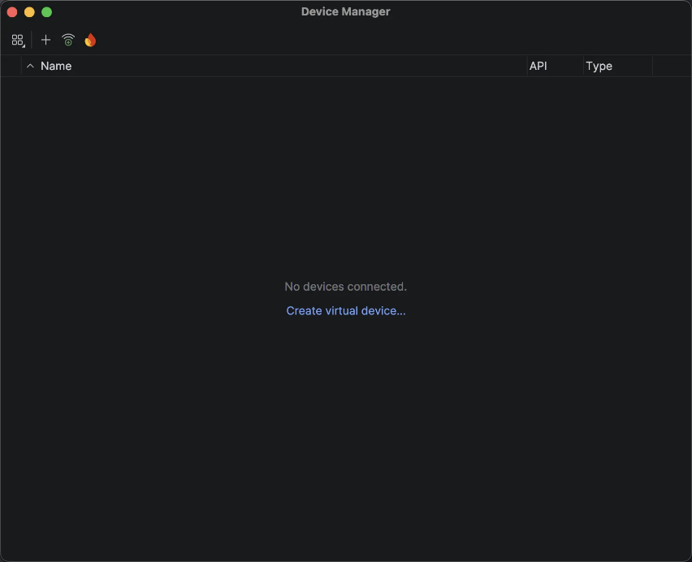
3.Under Add device, choose the type of hardware you'd like to emulate. We recommend testing against a variety of devices, but if you're unsure where to start, the newest device in the Pixel line could be a good choice.
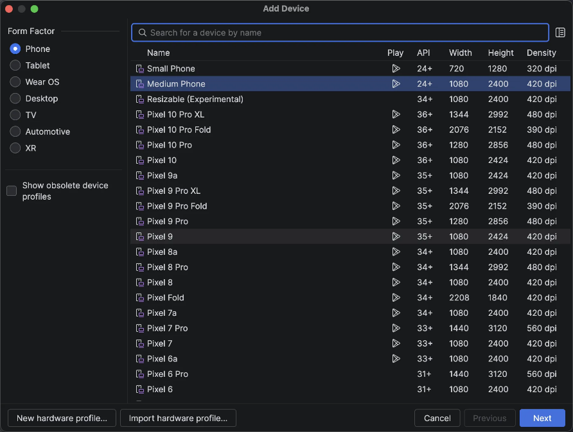
4.Select an OS version to load on the emulator (probably one of the system images), and download the image (if required).
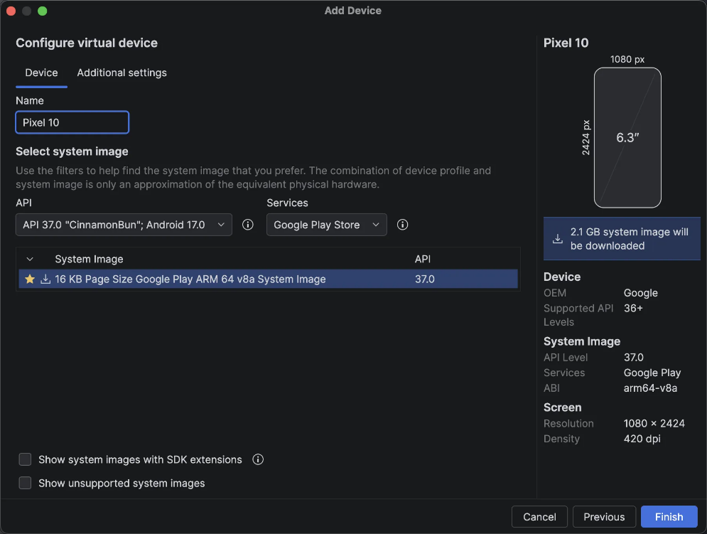
5.Change any other settings you'd like, and press Finish to create the emulator. You can now run this emulator anytime by pressing the Play button in the Device Manager window.

FOLDER STRUCTURE
A folder structure is the organized arrangement of files and folders inside a software project.
In React Native, a good folder structure helps you keep components, screens, assets, navigation, services, and other files organized.

1. Basic React Native Folder Structure
A simple React Native project can be organized like this:
MY-REACT-NATIVE-APP
│
├── android/
├── ios/
├── src/
│ ├── components/
│ ├── screens/
│ ├── navigation/
│ ├── assets/
│ ├── services/
│ ├── utils/
│ └── styles/
│
├── App.js
├── package.json
├── package-lock.json
├── babel.config.js
├── metro.config.js
└── .gitignore

2. android/ Folder
- The android folder contains the native Android project.
- It is used when React Native needs to interact with Android-specific code and configuration.
- It contains files related to:
  - Android application configuration
  - Gradle
  - Android Manifest
  - Native Android code
  - Android permissions
  - Android build configuration
Example:
android/
├── app/
├── gradle/
├── build.gradle
├── settings.gradle
└── gradlew

Important
Even though you are writing React Native code, the application ultimately runs as a native Android application.

3. ios/ Folder
- The ios folder contains the native iOS project.
- It is used for iOS-specific configuration and native code.
- It contains things such as:
  - Xcode project files
  - iOS configuration
  - Native iOS code
  - iOS permissions
  - iOS build settings
Example:
ios/
├── MyApp/
├── MyApp.xcodeproj/
├── MyApp.xcworkspace/
└── Podfile

Important
You usually don't modify this folder when doing normal React Native development. You work here when you need native iOS configuration or native modules.

4. src/ Folder
The src folder is commonly used to store the main application source code.
React Native does not require a src folder by default. It is a project organization convention.

A larger application can have:
src/
├── components/
├── screens/
├── navigation/
├── assets/
├── services/
├── utils/
├── hooks/
├── context/
└── styles/

5. components/ Folder
The components folder contains reusable UI components.
For example:
components/
├── Button.js
├── Header.js
├── Input.js
└── Card.js

Example:
<Button title="Login" />
Instead of creating the same button repeatedly, you create it once and reuse it.

6. screens/ Folder
The screens folder contains the major screens/pages of the application.
For example:

screens/
├── HomeScreen.js
├── LoginScreen.js
├── RegisterScreen.js
├── ProfileScreen.js
└── SettingsScreen.js

A screen normally represents a complete application view.
For example:
LoginScreen
↓
User enters email/password
↓
Login
↓
HomeScreen

7. navigation/ Folder
This folder contains navigation-related code.
For example:
navigation/
├── AppNavigator.js
├── AuthNavigator.js
└── TabNavigator.js

It can control navigation such as:
Login
↓
Home
↓
Profile
↓
Settings
React Native applications commonly use navigation libraries such as React Navigation, while Expo applications can also use Expo Router.

8. assets/ Folder
The assets folder contains resources used by the application.
For example:
assets/
├── images/
├── icons/
├── fonts/
└── animations/

Example:
assets/
├── images/
│ ├── logo.png
│ └── profile.png
│
├── icons/
│ ├── home.png
│ └── user.png
│
└── fonts/
└── Poppins-Regular.ttf

9. services/ Folder
The services folder is commonly used for API and external-service related code.
For example:

services/
├── api.js
├── authService.js
└── userService.js
Example:
React Native App
↓
authService.js
↓
Backend API
↓
Database

This keeps API-related logic separate from UI components.

10. utils/ Folder
utils contains reusable utility/helper functions.
For example:
utils/
├── validation.js
├── dateFormatter.js
└── storage.js

These functions can be used in different parts of the application.

11. styles/ Folder
This folder can contain reusable styling files.
For example:
styles/
├── colors.js
├── typography.js
├── spacing.js
└── commonStyles.js

This helps maintain consistent styling throughout the application.

12. hooks/ Folder
For reusable custom React hooks:
hooks/
├── useAuth.js
├── useFetch.js
└── useNetwork.js

Example:
const { data, loading } = useFetch(url);

13. context/ Folder
If you use React Context API, you can keep context-related files here.
context/
├── AuthContext.js
└── ThemeContext.js
For example:
AuthContext
↓
User authentication state
↓
Multiple screens/components

14. App.js
App.js is commonly the main/root component of a React Native application.
Example:
const App = () => {
return (
<HomeScreen />
);
};

export default App;
The exact entry setup can vary depending on whether you use the Community CLI, Expo, or Expo Router.

15. package.json
package.json contains important project information.
It can contain:
- Project name
- Version
- Scripts
- Dependencies
- Development dependencies
- Package configuration
Example:
{
"name": "my-app",
"version": "1.0.0",
"scripts": {
"start": "react-native start"
}
}

16. package-lock.json
- Created by npm.
- Records the specific dependency versions resolved for the project.
- Helps npm reproduce the dependency tree consistently.
You normally do not manually edit this file.

17. babel.config.js
Babel is used to transform JavaScript/JSX code into code that can be processed by the React Native toolchain.
Example:
Your JSX / JavaScript
↓
Babel
↓
Transformed JavaScript
↓
React Native toolchain

18. metro.config.js
Metro is the JavaScript bundler used by React Native.
It:
- Processes project JavaScript
- Resolves dependencies
- Builds the JavaScript bundle
- Supports React Native's development workflow
metro.config.js is used to customize Metro configuration when required.

19. .gitignore
.gitignore tells Git which files/folders should not be tracked.
For example:
node_modules/
.gradle/
build/
.env
This prevents unnecessary or sensitive files from being committed.

Complete Recommended Structure
For learning and medium-sized React Native projects, you can use:

MY-REACT-NATIVE-APP
│
├── android/
│
├── ios/
│
├── src/
│ │
│ ├── assets/
│ │ ├── images/
│ │ ├── icons/
│ │ └── fonts/
│ │
│ ├── components/
│ │ ├── Button/
│ │ ├── Header/
│ │ └── Card/
│ │
│ ├── screens/
│ │ ├── HomeScreen.js
│ │ ├── LoginScreen.js
│ │ └── ProfileScreen.js
│ │
│ ├── navigation/
│ │ └── AppNavigator.js
│ │
│ ├── services/
│ │ ├── api.js
│ │ └── authService.js
│ │
│ ├── hooks/
│ │ └── useAuth.js
│ │
│ ├── context/
│ │ └── AuthContext.js
│ │
│ ├── utils/
│ │ └── validation.js
│ │
│ └── styles/
│ ├── colors.js
│ └── commonStyles.js
│
├── App.js
├── package.json
├── package-lock.json
├── babel.config.js
├── metro.config.js
└── .gitignore

Easy way to remember
android/ → Android native files
ios/ → iOS native files
src/ → Application source code
components/ → Reusable UI
screens/ → Application screens
navigation/ → Screen navigation
assets/ → Images, icons, fonts
services/ → API/external services
hooks/ → Custom React hooks
context/ → Shared React state
utils/ → Helper functions
styles/ → Common styles
App.js → Root application component
package.json → Dependencies & scripts
One important point: this is a recommended scalable structure, not a mandatory React Native structure. React Native does not require you to create every src subfolder. You add folders according to the size and requirements of your application.

A folder structure is the organized arrangement of files and folders inside a software project.
In React Native, a good folder structure helps you keep components, screens, assets, navigation, services, and other files organized.

1. Basic React Native Folder Structure
A simple React Native project can be organized like this:
MY-REACT-NATIVE-APP
│
├── android/
├── ios/
├── src/
│ ├── components/
│ ├── screens/
│ ├── navigation/
│ ├── assets/
│ ├── services/
│ ├── utils/
│ └── styles/
│
├── App.js
├── package.json
├── package-lock.json
├── babel.config.js
├── metro.config.js
└── .gitignore

2. android/ Folder
- The android folder contains the native Android project.
- It is used when React Native needs to interact with Android-specific code and configuration.
- It contains files related to:
  - Android application configuration
  - Gradle
  - Android Manifest
  - Native Android code
  - Android permissions
  - Android build configuration
Example:
android/
├── app/
├── gradle/
├── build.gradle
├── settings.gradle
└── gradlew
Important
Even though you are writing React Native code, the application ultimately runs as a native Android application.

3. ios/ Folder
- The ios folder contains the native iOS project.
- It is used for iOS-specific configuration and native code.
- It contains things such as:
  - Xcode project files
  - iOS configuration
  - Native iOS code
  - iOS permissions
  - iOS build settings
Example:
ios/
├── MyApp/
├── MyApp.xcodeproj/
├── MyApp.xcworkspace/
└── Podfile
Important
You usually don't modify this folder when doing normal React Native development. You work here when you need native iOS configuration or native modules.

4. src/ Folder
The src folder is commonly used to store the main application source code.
React Native does not require a src folder by default. It is a project organization convention.
A larger application can have:
src/
├── components/
├── screens/
├── navigation/
├── assets/
├── services/
├── utils/
├── hooks/
├── context/
└── styles/

5. components/ Folder
The components folder contains reusable UI components.
For example:
components/
├── Button.js
├── Header.js
├── Input.js
└── Card.js
Example:
<Button title="Login" />
Instead of creating the same button repeatedly, you create it once and reuse it.

6. screens/ Folder
The screens folder contains the major screens/pages of the application.
For example:
screens/
├── HomeScreen.js
├── LoginScreen.js
├── RegisterScreen.js
├── ProfileScreen.js
└── SettingsScreen.js
A screen normally represents a complete application view.
For example:
LoginScreen
↓
User enters email/password
↓
Login
↓
HomeScreen

7. navigation/ Folder
This folder contains navigation-related code.
For example:
navigation/
├── AppNavigator.js
├── AuthNavigator.js
└── TabNavigator.js
It can control navigation such as:
Login
↓
Home
↓
Profile
↓
Settings
React Native applications commonly use navigation libraries such as React Navigation, while Expo applications can also use Expo Router.

8. assets/ Folder
The assets folder contains resources used by the application.
For example:
assets/
├── images/
├── icons/
├── fonts/
└── animations/
Example:
assets/
├── images/
│ ├── logo.png
│ └── profile.png
│
├── icons/
│ ├── home.png
│ └── user.png
│
└── fonts/
└── Poppins-Regular.ttf

9. services/ Folder
The services folder is commonly used for API and external-service related code.
For example:
services/
├── api.js
├── authService.js
└── userService.js
Example:
React Native App
↓
authService.js
↓
Backend API
↓
Database
This keeps API-related logic separate from UI components.

10. utils/ Folder
utils contains reusable utility/helper functions.
For example:
utils/
├── validation.js
├── dateFormatter.js
└── storage.js
These functions can be used in different parts of the application.

11. styles/ Folder
This folder can contain reusable styling files.
For example:
styles/
├── colors.js
├── typography.js
├── spacing.js
└── commonStyles.js
This helps maintain consistent styling throughout the application.

12. hooks/ Folder
For reusable custom React hooks:
hooks/
├── useAuth.js
├── useFetch.js
└── useNetwork.js
Example:
const { data, loading } = useFetch(url);

13. context/ Folder
If you use React Context API, you can keep context-related files here.
context/
├── AuthContext.js
└── ThemeContext.js
For example:
AuthContext
↓
User authentication state
↓
Multiple screens/components

14. App.js
App.js is commonly the main/root component of a React Native application.
Example:
const App = () => {
return (
<HomeScreen />
);
};

export default App;
The exact entry setup can vary depending on whether you use the Community CLI, Expo, or Expo Router.

15. package.json
package.json contains important project information.
It can contain:
- Project name
- Version
- Scripts
- Dependencies
- Development dependencies
- Package configuration
Example:
{
"name": "my-app",
"version": "1.0.0",
"scripts": {
"start": "react-native start"
}
}

16. package-lock.json
- Created by npm.
- Records the specific dependency versions resolved for the project.
- Helps npm reproduce the dependency tree consistently.
You normally do not manually edit this file.

17. babel.config.js
Babel is used to transform JavaScript/JSX code into code that can be processed by the React Native toolchain.
Example:
Your JSX / JavaScript
↓
Babel
↓
Transformed JavaScript
↓
React Native toolchain

18. metro.config.js
Metro is the JavaScript bundler used by React Native.
It:
- Processes project JavaScript
- Resolves dependencies
- Builds the JavaScript bundle
- Supports React Native's development workflow
metro.config.js is used to customize Metro configuration when required.

19. .gitignore
.gitignore tells Git which files/folders should not be tracked.
For example:
node_modules/
.gradle/
build/
.env
This prevents unnecessary or sensitive files from being committed.

Complete Recommended Structure
For learning and medium-sized React Native projects, you can use:
MY-REACT-NATIVE-APP
│
├── android/
│
├── ios/
│
├── src/
│ │
│ ├── assets/
│ │ ├── images/
│ │ ├── icons/
│ │ └── fonts/
│ │
│ ├── components/
│ │ ├── Button/
│ │ ├── Header/
│ │ └── Card/
│ │
│ ├── screens/
│ │ ├── HomeScreen.js
│ │ ├── LoginScreen.js
│ │ └── ProfileScreen.js
│ │
│ ├── navigation/
│ │ └── AppNavigator.js
│ │
│ ├── services/
│ │ ├── api.js
│ │ └── authService.js
│ │
│ ├── hooks/
│ │ └── useAuth.js
│ │
│ ├── context/
│ │ └── AuthContext.js
│ │
│ ├── utils/
│ │ └── validation.js
│ │
│ └── styles/
│ ├── colors.js
│ └── commonStyles.js
│
├── App.js
├── package.json
├── package-lock.json
├── babel.config.js
├── metro.config.js
└── .gitignore
Easy way to remember
android/ → Android native files
ios/ → iOS native files
src/ → Application source code
components/ → Reusable UI
screens/ → Application screens
navigation/ → Screen navigation
assets/ → Images, icons, fonts
services/ → API/external services
hooks/ → Custom React hooks
context/ → Shared React state
utils/ → Helper functions
styles/ → Common styles
App.js → Root application component
package.json → Dependencies & scripts
One important point: this is a recommended scalable structure, not a mandatory React Native structure. React Native does not require you to create every src subfolder. You add folders according to the size and requirements of your application.

REACT NATIVE PROJECT NAMING CONVATIONS

-Naming conventions are rules used to give projects, folders, files, components, variables, functions, and other elements consistent and readable names.

1. Project Name
Use a clear and meaningful project name.
Recommended
MyReactNativeApp
ExpenseTracker
TodoApp
WeatherApp
FoodDeliveryApp
GymApp
Convention
- Use PascalCase for the project name.
- Do not use spaces.
- Avoid unnecessary special characters.
- Keep the name meaningful and easy to understand.
PascalCase
↓
MyReactNativeApp
Avoid
my react native app ❌
my_react_native_app ❌
my-react-native-app ❌
My React Native App ❌

2. Folder Naming
For folders inside your source code, use lowercase names.
src/
├── components/
├── screens/
├── navigation/
├── services/
├── hooks/
├── utils/
├── assets/
└── styles/
Convention
lowercase
↓
components
screens
services
navigation
-Avoid unnecessary uppercase folder names:
- Components/ ❌
- Screens/ ❌
- MyComponents/ ❌

3. Component File Naming
React components should generally use PascalCase.
Button.jsx
Header.jsx
UserCard.jsx
LoginForm.jsx
ProductCard.jsx
Example:
const UserCard = () => {
return (
<View>
<Text>User</Text>
</View>
);
};

export default UserCard;
Why PascalCase?
Because React components are used as custom elements:
<UserCard />
<LoginForm />
<ProductCard />

4. Screen Naming
Screen components should use PascalCase and normally end with Screen.
HomeScreen.jsx
LoginScreen.jsx
RegisterScreen.jsx
ProfileScreen.jsx
SettingsScreen.jsx
ProductDetailsScreen.jsx
Example:
const HomeScreen = () => {
return (
<View>
<Text>Home</Text>
</View>
);
};

5. Component Folder Naming
For larger reusable components, you can create a folder using the component name.
components/
├── Button/
│ ├── Button.jsx
│ └── Button.styles.js
│
├── Header/
│ ├── Header.jsx
│ └── Header.styles.js
│
└── UserCard/
├── UserCard.jsx
└── UserCard.styles.js
The folder can use PascalCase when it represents a specific component.

6. JavaScript File Naming
For general JavaScript files, use camelCase or PascalCase depending on what the file represents.
Utility/service files
- api.js
- authService.js
- userService.js
- dateFormatter.js
- validation.js
- storage.js
Component files
- Button.jsx
- UserCard.jsx
- LoginForm.jsx

7. Hook Naming
Custom React Hooks must start with:
use
Use camelCase.
Examples:
- useAuth.js
- useFetch.js
- useNetwork.js
- useTheme.js
- useForm.js
- Example:
const useAuth = () => {
// hook logic
};
Then:
const { user } = useAuth();
Important
-The use prefix is important because React identifies custom Hooks through this naming convention and the Rules of Hooks apply to them.

8. Function Naming
-Use camelCase for functions.
- handleLogin()
- fetchUsers()
- getProducts()
- calculateTotal()
- validateForm()
- handleSubmit()
Example:
const handleLogin = () => {
// login logic
};
Event handler convention
Common patterns:
- handleClick()
- handleSubmit()
- handleChange()
- handlePress()
- handleLogin()
- handleLogout()

9. Variable Naming
Use camelCase.
- const userName = "Amol";
- const userEmail = "user@example.com";
- const productList = [];
- const isLoggedIn = true;
- const totalPrice = 500;
Avoid:
- const UserName = "Amol"; // ❌
- const user_name = "Amol"; // ❌
- const user-name = "Amol"; // ❌

10. Boolean Naming
Boolean variables should clearly indicate a true/false value.
Common prefixes:
is
has
can
should
Examples:
- const isLoading = true;
- const isLoggedIn = false;
- const hasPermission = true;
- const canEdit = false;
- const shouldRefresh = true;
- This makes the code easier to understand.

11. Constants Naming
There are two common approaches.
Regular project constants
Use camelCase:
const apiUrl = "...";
const maxRetryCount = 3;
True global/configuration constants
You may use UPPER_SNAKE_CASE:
const API_URL = "...";
const MAX_RETRY_COUNT = 3;
const DEFAULT_TIMEOUT = 5000;
The important thing is to be consistent within the project.

12. Props Naming
-Use camelCase.
<UserCard
userName="Amol"
userAge={25}
isActive={true}
/>
Component:
const UserCard = ({ userName, userAge, isActive }) => {
// ...
};

13. State Naming
-Use meaningful camelCase names.
const [user, setUser] = useState(null);

const [isLoading, setIsLoading] = useState(false);

const [userName, setUserName] = useState("");

const [products, setProducts] = useState([]);
Common pattern
[value, setValue]
Examples:
user → setUser
products → setProducts
isLoading → setIsLoading
userName → setUserName

14. Navigation Naming
Navigation files can use PascalCase.
navigation/
├── AppNavigator.jsx
├── AuthNavigator.jsx
├── StackNavigator.jsx
└── TabNavigator.jsx
Screen names should also be meaningful:
HomeScreen
LoginScreen
ProfileScreen
SettingsScreen

15. Context Naming
Context files can use PascalCase.
context/
├── AuthContext.jsx
├── ThemeContext.jsx
└── CartContext.jsx
Example:
const AuthContext = createContext();

export default AuthContext;

16. Service Naming
Use descriptive camelCase names.
services/
├── api.js
├── authService.js
├── userService.js
├── productService.js
└── paymentService.js
Examples:
authService
userService
productService

17. Asset Naming
Use simple lowercase names.
assets/
├── images/
│ ├── logo.png
│ ├── profile-image.png
│ └── banner-image.png
│
└── icons/
├── home-icon.png
├── user-icon.png
└── search-icon.png
Avoid spaces:
Profile Image.png ❌
My Logo.png ❌
Prefer:
profile-image.png ✅
my-logo.png ✅

18. Style File Naming
For component-specific styles:
Button.styles.js
Header.styles.js
LoginScreen.styles.js
Or, if your project uses a different styling architecture, you can keep:
buttonStyles.js
headerStyles.js
The important thing is consistency.

19. Redux File Naming
If you use Redux Toolkit:
store/
├── store.js
└── slices/
├── authSlice.js
├── userSlice.js
└── productSlice.js
Use:
authSlice
userSlice
productSlice
rather than vague names such as:
file1.js
data.js
redux.js

20. Environment Files
Environment/configuration files commonly use:
.env
.env.development
.env.production
Do not commit secrets such as API keys or private credentials to GitHub.
Use .gitignore appropriately.

Quick Naming Table
Item | Convention | Example
Project | PascalCase | MyReactNativeApp
Folder | lowercase | components
Component | PascalCase | UserCard.jsx
Screen | PascalCase + Screen | HomeScreen.jsx
Function | camelCase | handleLogin()
Variable | camelCase | userName
Boolean | camelCase + prefix | isLoading
Hook | use + camelCase | useAuth.js
Context | PascalCase | AuthContext.jsx
Service | camelCase | authService.js
Slice | camelCase + Slice | authSlice.js
Asset | lowercase | profile-image.png
Constant | UPPER_SNAKE_CASE when appropriate | API_URL

Recommended Structure With Naming
MyReactNativeApp/
│
├── android/
├── ios/
│
├── src/
│ │
│ ├── assets/
│ │ ├── images/
│ │ │ ├── logo.png
│ │ │ └── profile-image.png
│ │ └── icons/
│ │ └── home-icon.png
│ │
│ ├── components/
│ │ ├── Button.jsx
│ │ ├── Header.jsx
│ │ └── UserCard.jsx
│ │
│ ├── screens/
│ │ ├── HomeScreen.jsx
│ │ ├── LoginScreen.jsx
│ │ └── ProfileScreen.jsx
│ │
│ ├── navigation/
│ │ └── AppNavigator.jsx
│ │
│ ├── services/
│ │ ├── api.js
│ │ └── authService.js
│ │
│ ├── hooks/
│ │ └── useAuth.js
│ │
│ ├── context/
│ │ └── AuthContext.jsx
│ │
│ └── utils/
│ └── validation.js
│
├── App.jsx
├── package.json
├── babel.config.js
└── .gitignore
Main Rule to Remember
Project → PascalCase
Component → PascalCase
Screen → PascalCase + Screen
Folder → lowercase
Function → camelCase
Variable → camelCase
Hook → use + camelCase
Boolean → is / has / can / should
Service → camelCase + Service
Context → PascalCase + Context
Redux Slice → camelCase + Slice
Assets → lowercase
The most important thing is consistency. A team can choose slightly different conventions, but once a project adopts a convention, use it consistently throughout the project.

RUN REACT NATIVE APP DIFFERENT PLATFORMS
-There are three common methods:
  - Physical Android Device using USB
  - Physical Android Device using Expo Go
  - Android Emulator

1. Run React Native App on Physical Android Device Using USB
- Step 1: Enable Developer Options
  - Open Settings on the Android device.
  - Go to About Phone.
  - Find Build Number.
  - Tap Build Number 7 times.
  - Developer Options will be enabled.
- Step 2: Enable USB Debugging
  - Open Settings → Developer Options.
  - Enable USB Debugging.
  - Confirm the permission if prompted.
- Step 3: Connect Mobile Device
  - Connect the Android device to the computer using a USB cable.
  - Allow the USB Debugging permission on the mobile.
- Step 4: Check Device Connection
adb devices
- The connected device should appear as:
List of devices attached
XXXXXXXX device
- Step 5: Start the Development Server
npm start
- Step 6: Run the Application
npx react-native run-android
- The application will be built and installed on the connected Android device.
If you are connected via cable, do the following:
1. Goto > Settings > About Device
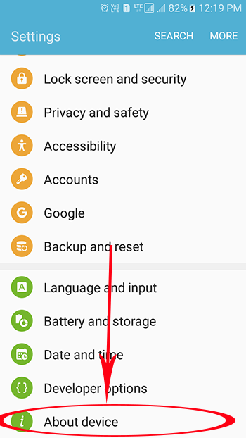
2. Then Software Info
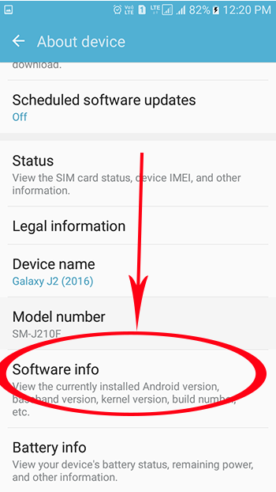

3. Then > Build Number
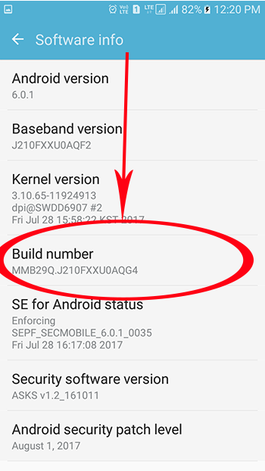
4. Now Tap (Click) multiple times on Build Number to Enable Developer Options
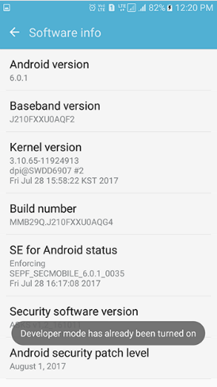
5. Here you go not the Developer Options will be visible in your Settings
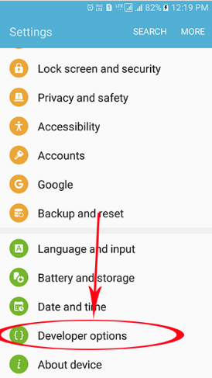

6. Now Go inside the Developer Options and Enable USB Debugging Mode.
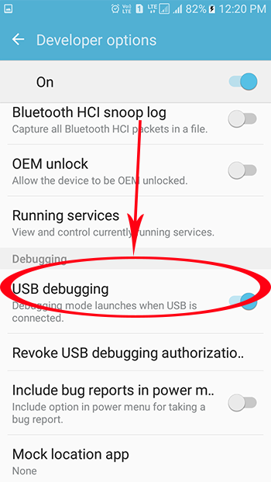

7. Open your terminal
On Windows open Android SDK Manger > Platform Tools
Type:
$ adb devices

This will show you the devices and simulator/virtual-devices that you have on you computer.

8. Forward requests from your device
Type:
$ adb reverse tcp:8081 tcp:8081

9. Run it
Type:
$ npm run android

-The app should appear on your device

2. Run React Native App Using Expo Go
- Step 1: Install Expo Go
  - Install the Expo Go application on the Android mobile device.
- Step 2: Connect to the Same Network
  - Connect the computer and mobile device to the same Wi-Fi network.
- Step 3: Start the Expo Development Server
npx expo start
- Step 4: Generate QR Code
  - Expo will display a QR code in the terminal/browser.
- Step 5: Scan the QR Code
  - Open Expo Go on the mobile device.
  - Scan the QR code.
- Step 6: Run the Application
  - Expo Go connects to the development server.
  - The React Native application opens on the mobile device.
- If the QR Code Does Not Connect
npx expo start --tunnel
- Scan the newly generated QR code using Expo Go.

3. Run React Native App on Android Emulator
- Step 1: Install Android Studio
  - Install Android Studio on the computer.
  - Ensure the required Android SDK components are installed.
- Step 2: Open Device Manager
  - Open Android Studio.
  - Go to Device Manager.
- Step 3: Create Virtual Device
  - Click Create Virtual Device.
  - Select a device model.
  - Select an Android system image.
  - Complete the AVD setup.
- Step 4: Start Emulator
  - Open Device Manager.
  - Click the Start ▶ button for the created virtual device.
  - Wait for the Android Emulator to start.
- Step 5: Start the Development Server
npm start
- Step 6: Run the Application
npx react-native run-android
- The application will be installed and launched inside the Android Emulator.

Set up React Native app on Android emulator
Here are the steps to create and run a React Native app on an Android emulator:
Open Android Studio and click on the Virtual Device Manager button in the More Actions dropdown, which is located in the Welcome to Android Studio section.
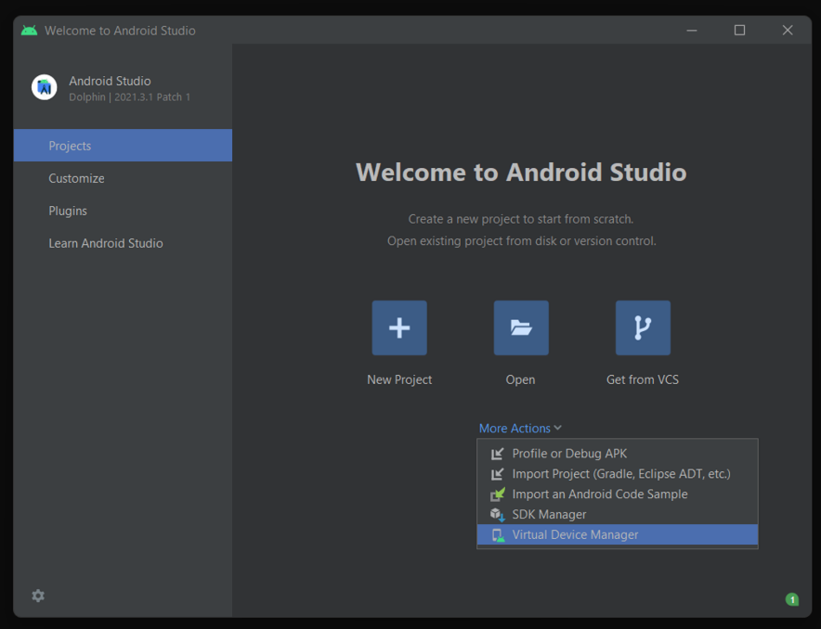
In the device manager window that pops up, click on the Create device button. This will create a new virtual device.
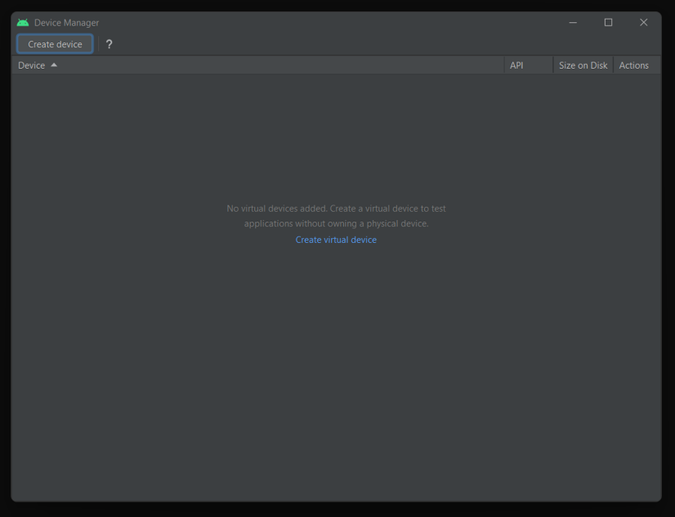
Select the type of device you want to emulate from the preset hardware profiles available. There are also options to import and create from scratch; however, for the scope of this post, we’ll go ahead with a Pixel 4 and click Next.
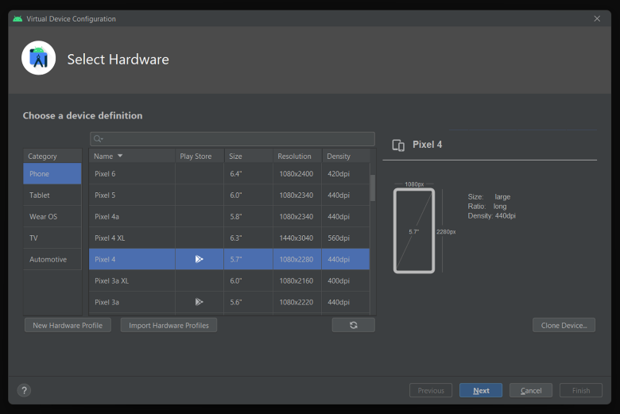
Select the version of Android you want to run on the emulator. We’ll proceed with the Android 12 (S) x86 image, as we’re running a Windows Intel x86 machine, and click Next.
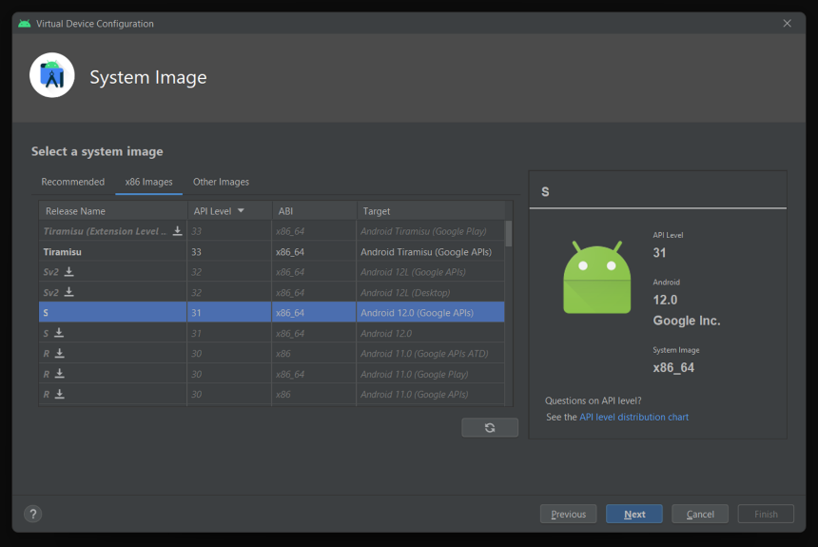
We can verify our choices and click Finish to create the emulator.
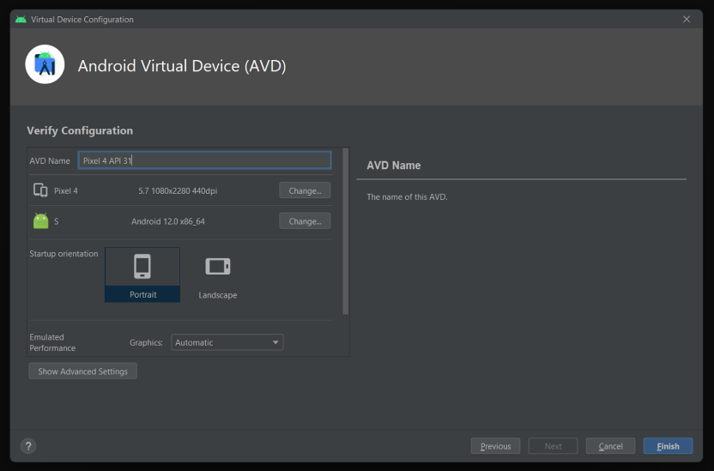
Once the emulator is created, we can start it by clicking the Play button in the device manager window.
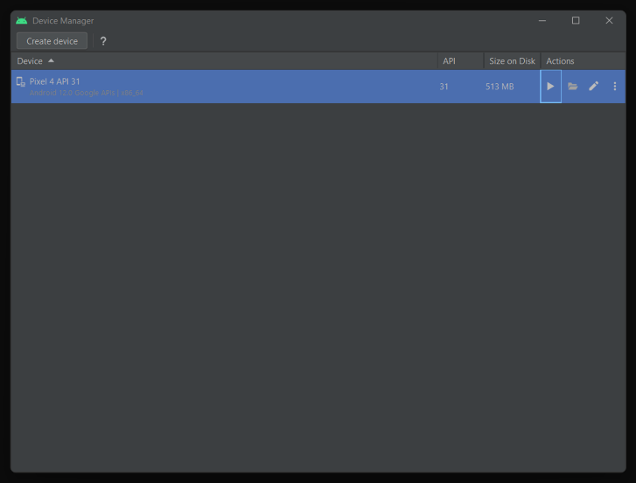
We’ll soon have the emulator for Android devices up and running. We can verify the same with the adb devices command we used earlier.
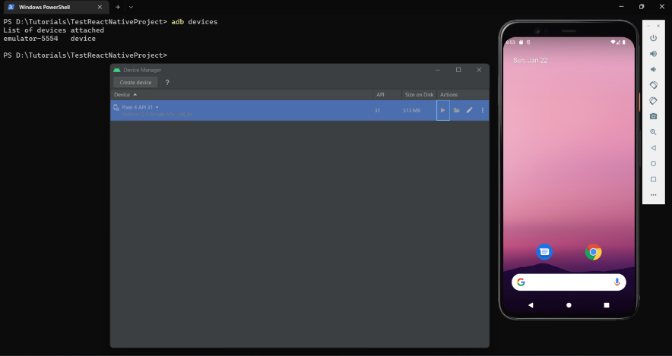
Start your app on the emulator
Now, we can run the following command to start the app on the emulator:
npx react-native run-android

The app will start on the emulator, and you can test it as if it were running on a real device.
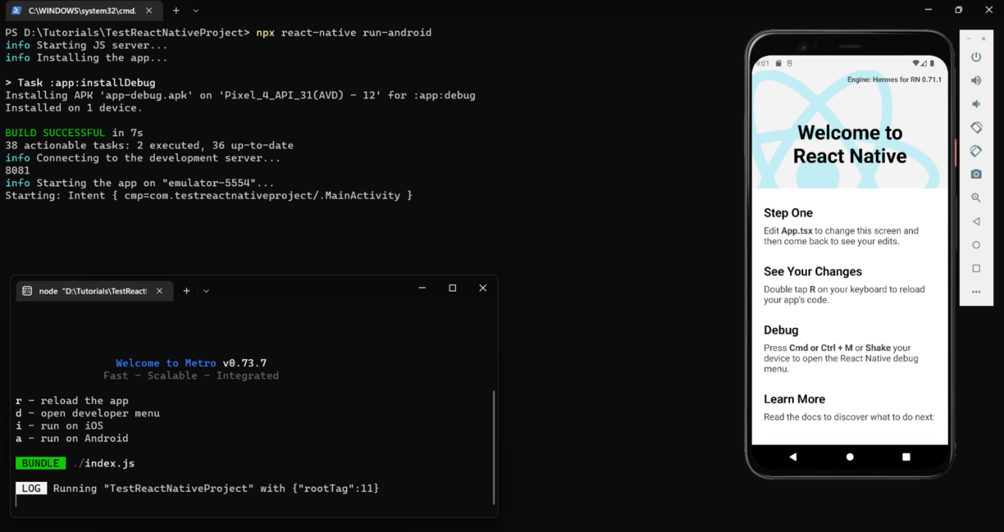

HOW TO TEST ON MULTIPLE DEVICES AT ONCE

As a developer, you may want to test your app on multiple devices to ensure that it’s compatible with a range of devices and platforms. Testing on both emulators and physical devices can help you identify any issues that may not be present on one device but may appear on another.
To test a React Native app on multiple devices at once, connect all the physical devices to your computer using USB cables. Run adb devices to verify.
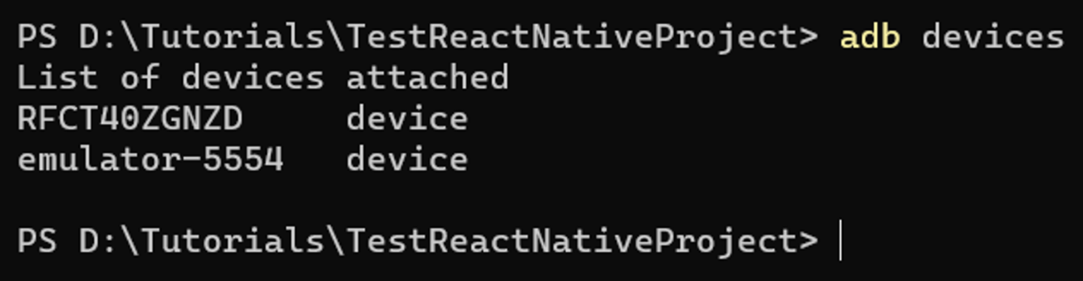
We can see that we have one physical device connected and one virtual device running on the emulator. Now, we can run the run-android command to start the app on basically all the available connected devices that Android Debug Bridge can identify:
npx react-native run-android
Instead of using this command, you can also test multiple devices using cloud-based services like AWS Device Farm, Firebase Test Lab, or Experitest.
Just for demonstration purposes, we used the Phone Link app on Windows to pull up the physical Android device’s screen on our screen along with the emulator.
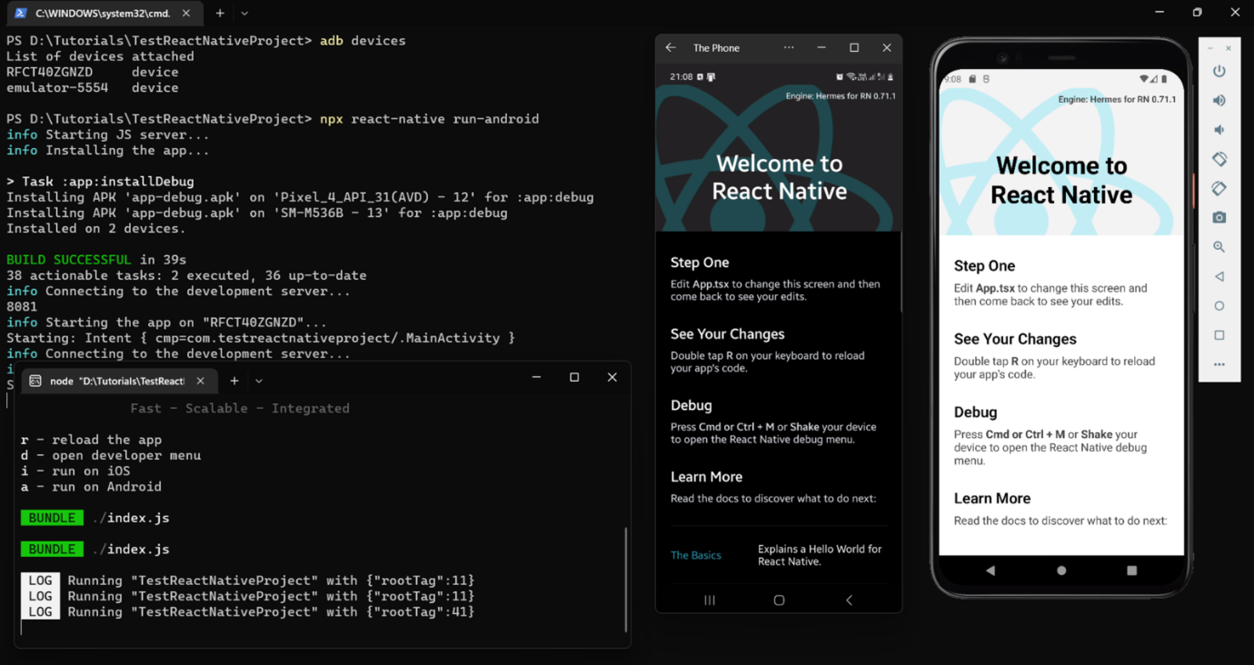
Testing on multiple devices can be challenging, as it can be time-consuming and require additional resources. Therefore, it’s important to prioritize the most important devices and platforms to test on and to use emulators and simulators to test on other devices that are less critical.

HOW TO TEST ON SPECIFIC DEVICES

You may want to test your React Native app on specific devices, such as a smartwatch, phone, or tablet to ensure that your app is compatible with those devices. You’ll also be able to make sure that the user experience is optimized for those specific devices.
We can create as many virtual devices as we want following the process described above for running React Native apps on an emulator.
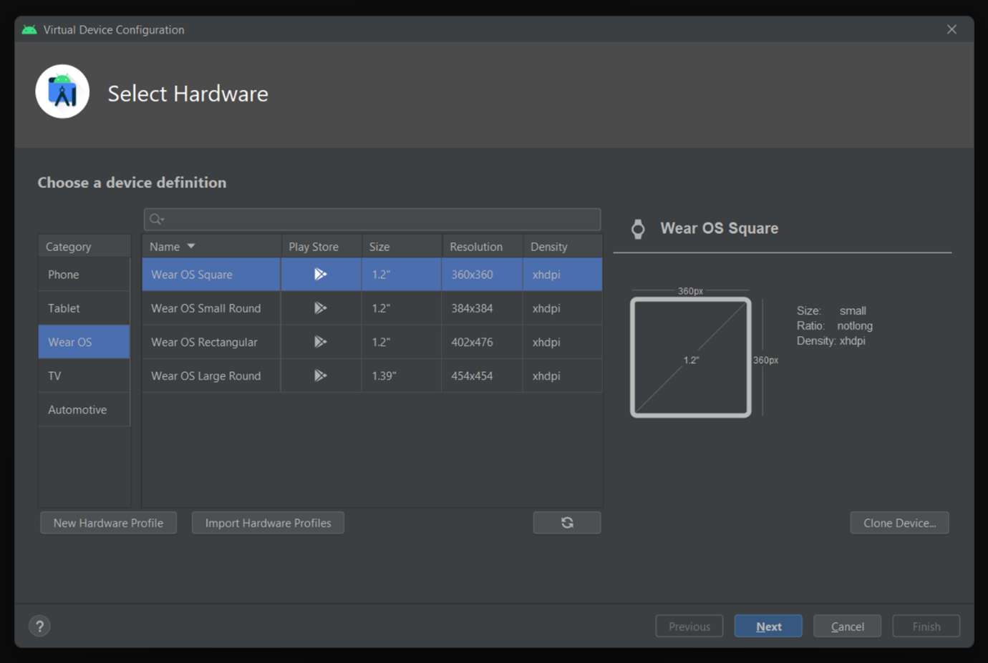
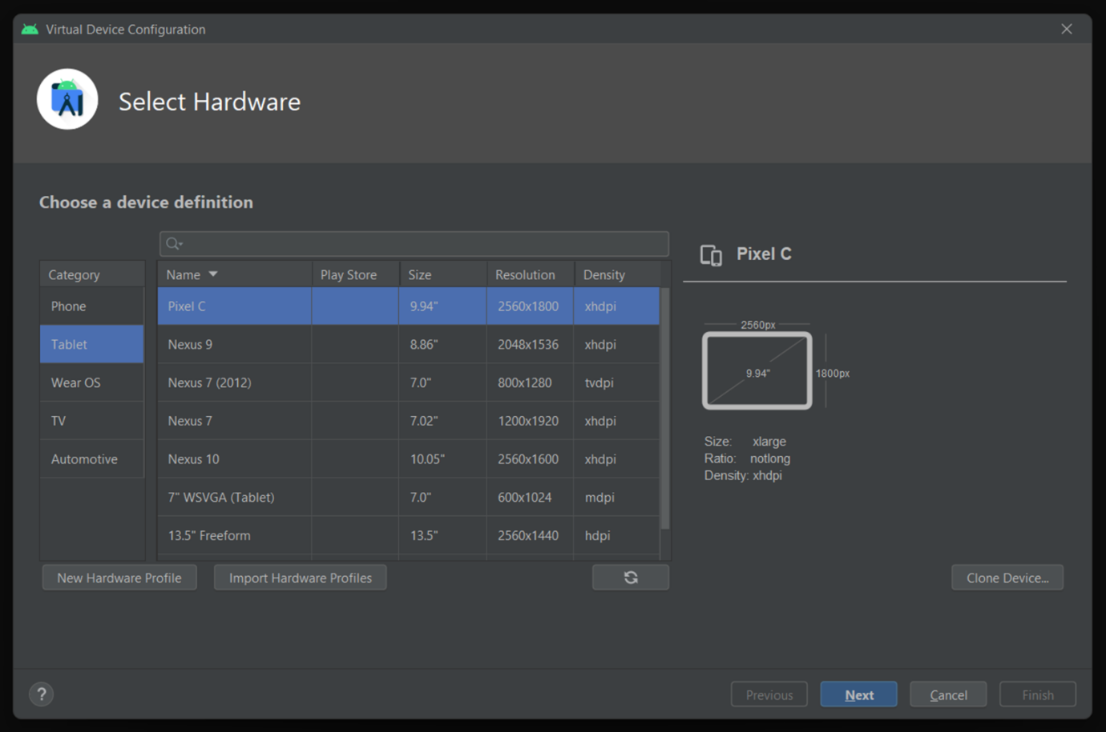
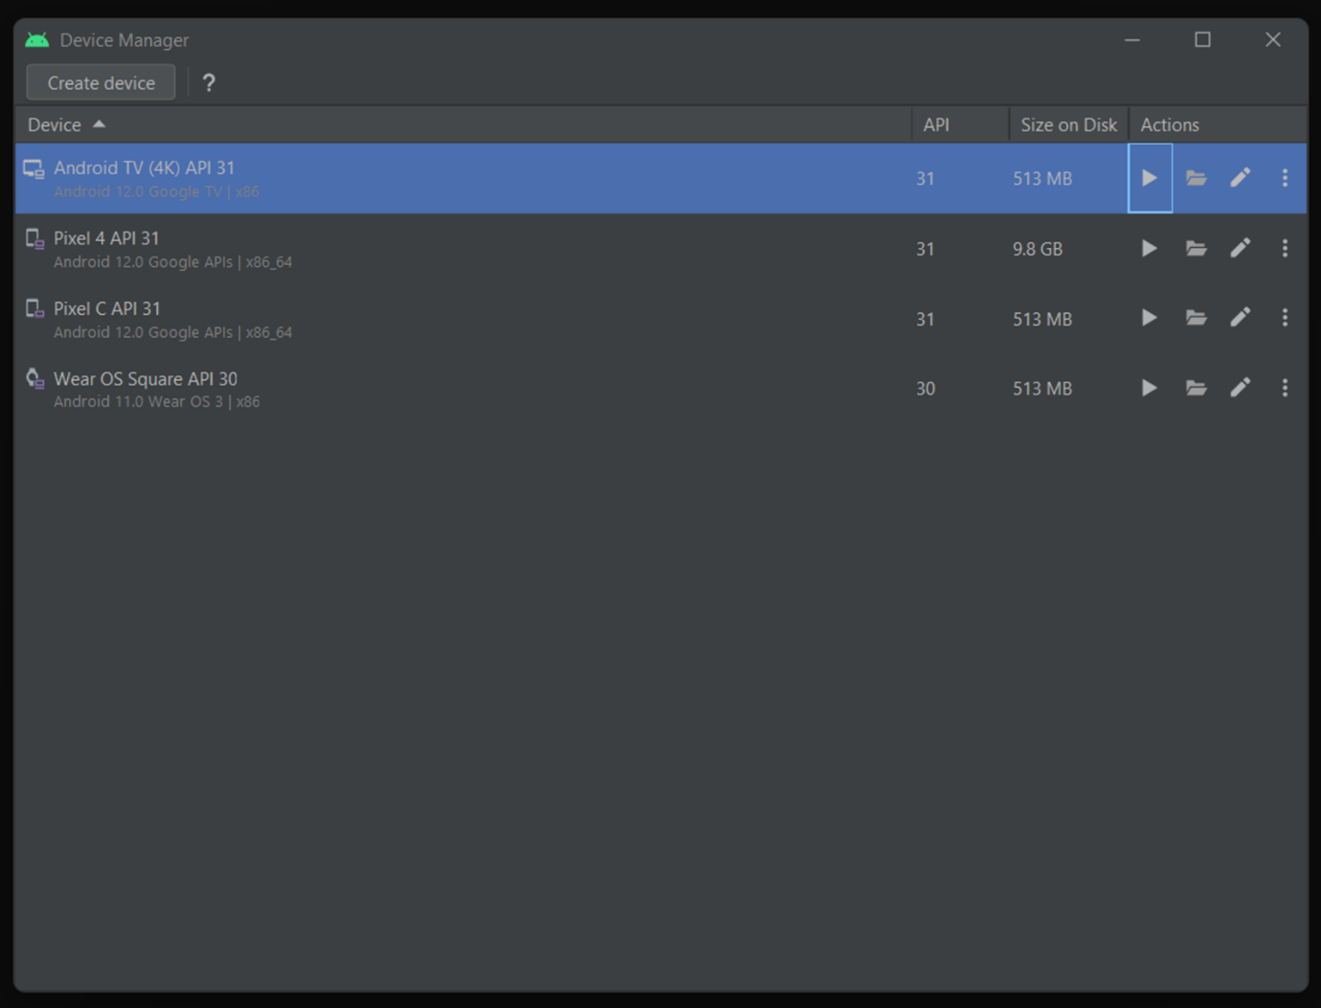
In this case, a list of device IDs of multiple running emulators is not enough to identify the devices. So, verify with adb devices -l.
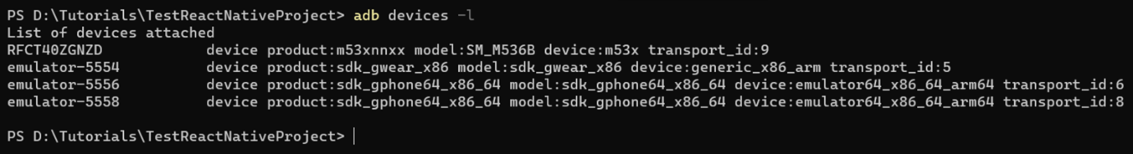
We can run our app on all running Android devices using the same command as before:
npx react-native run-android
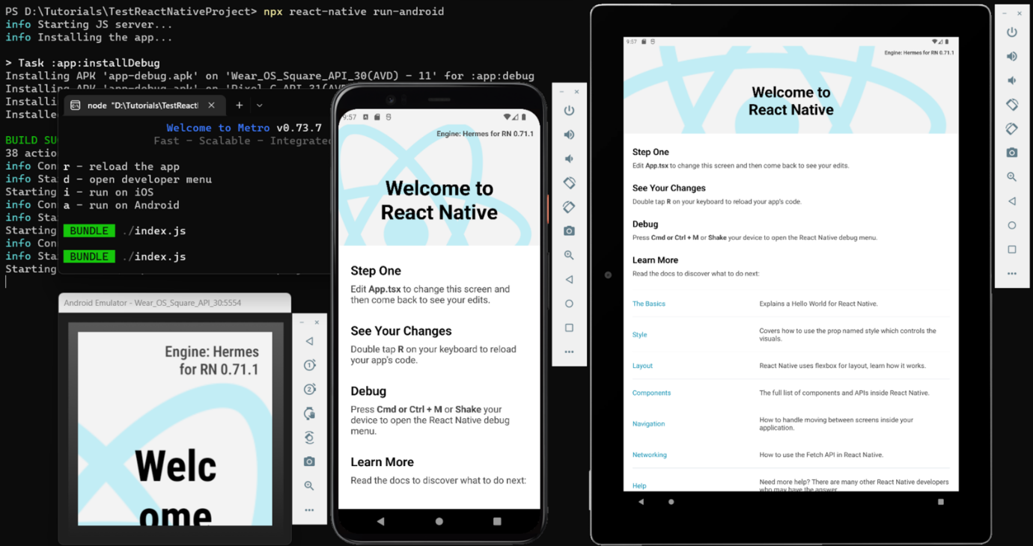
Or we can also run on specific devices with their device IDs. We can obtain these IDs in the output of the command adb devices -l.
npx react-native run-android --deviceId <device-id>
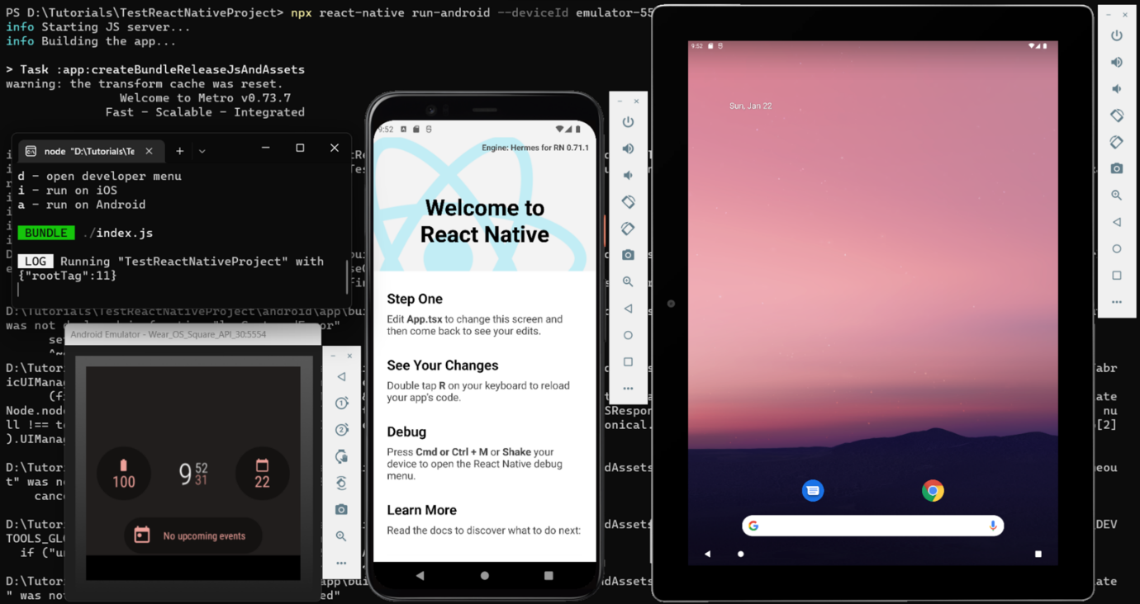
This command will build the app and install it on the specific device. The <device-id> should be replaced with the ID of the specific device you want to test on, which can be obtained by typing adb devices into the command prompt or terminal. Once the app is installed, it will start automatically on the specific device.

ENVIRONMENT VARIABLES, PATH & CONFIGURATION

1. Android SDK Configuration

- Android SDK (Software Development Kit) provides the tools, libraries, platform files, and build components required to develop Android applications.
- React Native uses the Android SDK to build, install, debug, and run Android applications.
- Default Android SDK location on Windows:
C:\Users\<Username>\AppData\Local\Android\Sdk
- Example:
C:\Users\amolp\AppData\Local\Android\Sdk

2. ANDROID_HOME Environment Variable

- ANDROID_HOME is an environment variable that points to the Android SDK installation directory.
- It allows development tools to locate the Android SDK without requiring the complete path every time.
- Variable name:
ANDROID_HOME
- Variable value:
C:\Users\amolp\AppData\Local\Android\Sdk
- ANDROID_HOME is commonly used by Android and React Native development tools to identify the SDK location.

3. PATH Environment Variable

- PATH is a Windows environment variable containing directories where executable commands can be found.
- Adding Android SDK tool directories to PATH allows commands such as adb and emulator to be executed from any Command Prompt or terminal.
- The following Android SDK directories should be added to PATH:
C:\Users\amolp\AppData\Local\Android\Sdk\platform-tools
C:\Users\amolp\AppData\Local\Android\Sdk\emulator

4. Platform Tools Path

- platform-tools contains Android debugging and device communication tools.
- The most important tool for React Native development is:
adb.exe
- adb stands for Android Debug Bridge.
- It is used to communicate between the computer and Android devices or emulators.
- Add the following directory to PATH:
C:\Users\amolp\AppData\Local\Android\Sdk\platform-tools
- Common command:
adb devices
- This command displays connected Android devices and running emulators.

5. Android Emulator Path

- The Android Emulator directory contains the tools required to start and manage Android Virtual Devices.
- Add the following directory to PATH:
C:\Users\amolp\AppData\Local\Android\Sdk\emulator
- Common commands:
emulator -list-avds
emulator -avd Pixel_4
- emulator -list-avds displays the available Android Virtual Devices.
- emulator -avd <AVD_NAME> starts a specific Android Virtual Device.

6. JAVA_HOME Configuration

- Java is required for the Android build process used by React Native.
- JAVA_HOME is an environment variable that points to the installed JDK (Java Development Kit).
- Example:
JAVA_HOME
C:\Program Files\Java\jdk-26.0.2
- The value of JAVA_HOME should point to the JDK root directory, not its bin directory.
- Example:
Correct:
C:\Program Files\Java\jdk-26.0.2
Incorrect:
C:\Program Files\Java\jdk-26.0.2\bin
- Java commands can be made available through PATH by adding:
C:\Program Files\Java\jdk-26.0.2\bin
- Verify Java configuration using:
java -version
javac -version

7. Android SDK Components
- The Android SDK installation contains several important components used during React Native development.
- Platform Tools
  - Provides adb and other Android debugging tools.
- Emulator
  - Provides commands for starting Android emulators.
- SDK Platforms
  - Contains Android platform files for specific Android API levels.
- SDK Build Tools
  - Contains tools required to compile and package Android applications.
- Android SDK Command-Line Tools
  - Provides command-line utilities for managing SDK components.
- Android Emulator
  - Allows Android applications to be tested without a physical Android device.

8. Android Virtual Device (AVD)
- AVD stands for Android Virtual Device.
- An AVD is a configuration that defines an Android emulator device.
- It can specify:
  - Device model
  - Android version
  - Screen resolution
  - RAM
  - Storage
  - Graphics configuration
- Example AVDs:
Pixel_4
Pixel_9_Pro
Small_Tablet
- List available AVDs:
emulator -list-avds
- Start an AVD:
emulator -avd Pixel_4

9. ADB Configuration
- ADB (Android Debug Bridge) is a command-line tool used to communicate with Android devices and emulators.
- ADB is located inside:
C:\Users\amolp\AppData\Local\Android\Sdk\platform-tools
- Check ADB version:
adb version
- Start the ADB server:
adb start-server
- Stop the ADB server:
adb kill-server
- Check connected devices:
adb devices

10. Verify Environment Configuration
- After modifying environment variables, close and reopen Command Prompt or VS Code so the new PATH values are loaded.
- Check Android SDK variable:
echo %ANDROID_HOME%
- Check Java variable:
echo %JAVA_HOME%
- Check ADB:
adb version
- Check available emulators:
emulator -list-avds
- Check connected devices:
adb devices

11. React Native / Expo Android Configuration
- Once Android SDK, Java, ADB, and Emulator are configured, React Native or Expo can communicate with Android devices and emulators.
- Start the Expo development server:
npx expo start
- Press:
a
- Expo attempts to open the application on a connected Android device or emulator.
- The basic flow is:
React Native / Expo
↓
Android SDK
↓
ADB
↓
Android Device / Emulator

12. Final Environment Variables
- ANDROID_HOME
C:\Users\amolp\AppData\Local\Android\Sdk
- JAVA_HOME
C:\Program Files\Java\jdk-26.0.2
- PATH – Android Platform Tools
C:\Users\amolp\AppData\Local\Android\Sdk\platform-tools
- PATH – Android Emulator
C:\Users\amolp\AppData\Local\Android\Sdk\emulator
- PATH – Java
C:\Program Files\Java\jdk-26.0.2\bin
Important
- ANDROID_HOME → points to the Android SDK.
- JAVA_HOME → points to the JDK.
- platform-tools → provides ADB.
- emulator → provides Android Emulator commands.
- PATH → allows these commands to be executed from any terminal.
- AVD → defines the virtual Android device.
- ADB → connects the development computer with the Android device/emulator.

ENVIRONMENT CONFIGURATION CHECK COMMANDS

1. Check Node.js
node -v
- Checks whether Node.js is installed and displays its installed version.
npm -v
- Checks whether npm (Node Package Manager) is installed and displays its version.

2. Check Java
java -version
- Checks whether Java is installed and displays the installed Java version.
javac -version
- Checks whether the Java Compiler (JDK) is installed and displays its version.

3. Check JAVA_HOME
echo %JAVA_HOME%
- Displays the location configured in the JAVA_HOME environment variable.
- It should point to the JDK installation directory.

4. Check Android SDK
echo %ANDROID_HOME%
- Displays the location configured in the ANDROID_HOME environment variable.
- It should point to the Android SDK directory.

5. Check ADB
adb version
- Checks whether Android Debug Bridge (ADB) is available and displays its version.
- ADB is used to communicate with Android devices and emulators.

6. Check Android Emulator
emulator -version
- Checks whether the Android Emulator command is available and displays its version.
emulator -list-avds
- Displays all Android Virtual Devices (AVDs) available on the computer.

7. Check Connected Android Devices
adb devices
- Displays Android devices and emulators currently detected by ADB.
- device means the device is connected and ready.
- offline means the device is detected but ADB communication is not currently working.

8. Check Expo
npx expo --version
- Checks whether Expo CLI through npx is available and displays the installed Expo version.
npx expo doctor
- Checks the Expo project for common configuration, dependency, and environment issues.

9. Check Android Tools in PATH
where adb
- Displays the location from which Windows is running adb.
where emulator
- Displays the location from which Windows is running the Android Emulator.

Quick Reference
Command | Purpose
node -v | Check Node.js
npm -v | Check npm
java -version | Check Java
javac -version | Check Java compiler
echo %JAVA_HOME% | Check Java configuration
echo %ANDROID_HOME% | Check Android SDK configuration
adb version | Check ADB
emulator -version | Check Android Emulator
emulator -list-avds | Check available AVDs
adb devices | Check connected Android devices
npx expo --version | Check Expo
npx expo doctor | Check Expo project
where adb | Check ADB PATH
where emulator | Check Emulator PATH

ANDROID STUDIO EMULATOR NOT SHOWING ON SCREEN

-On the First time when I run the adb then it not showing the emulator properly on the my Laptop screen.It shows like below.
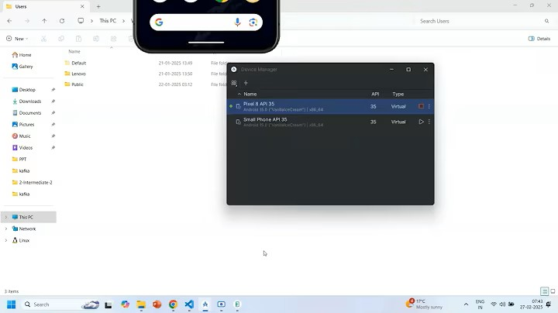
-For that I have proper step by step solution

1.Go to the c drive in that local appdata
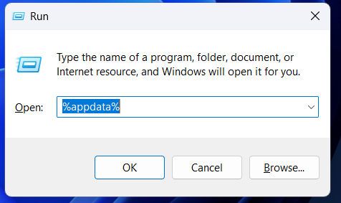
-This commands directly goes to the roaming inside the appdata.

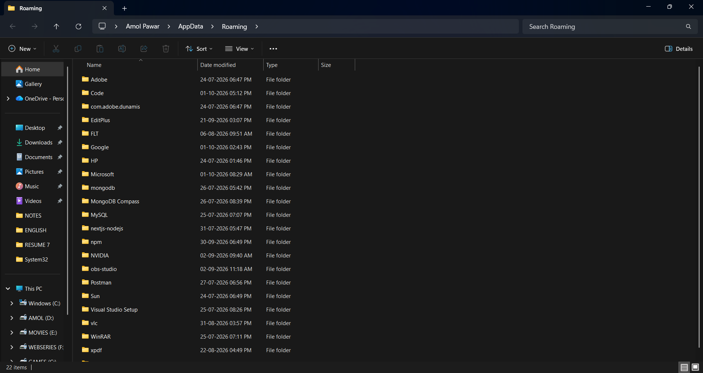

2.Then Click back Go to the local in the Appdata
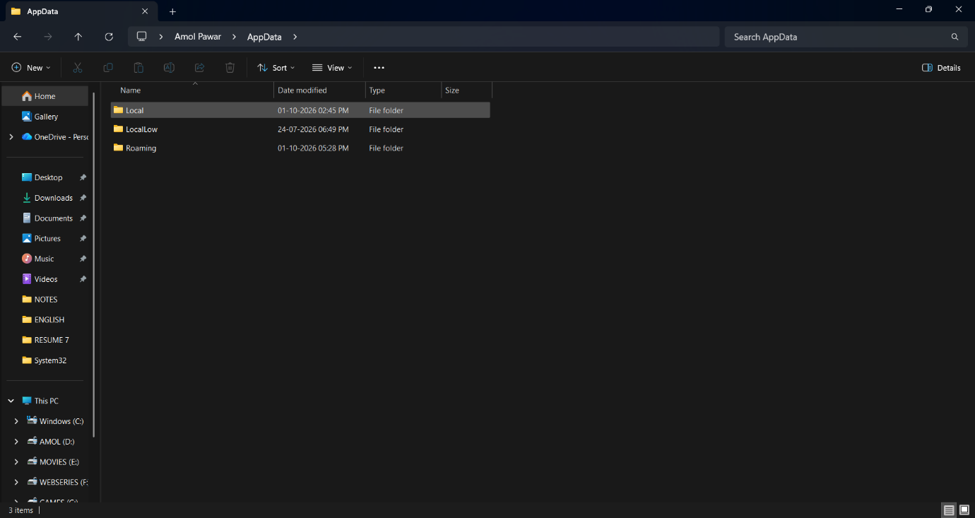

4.Then Inside the local go to the Android Folder
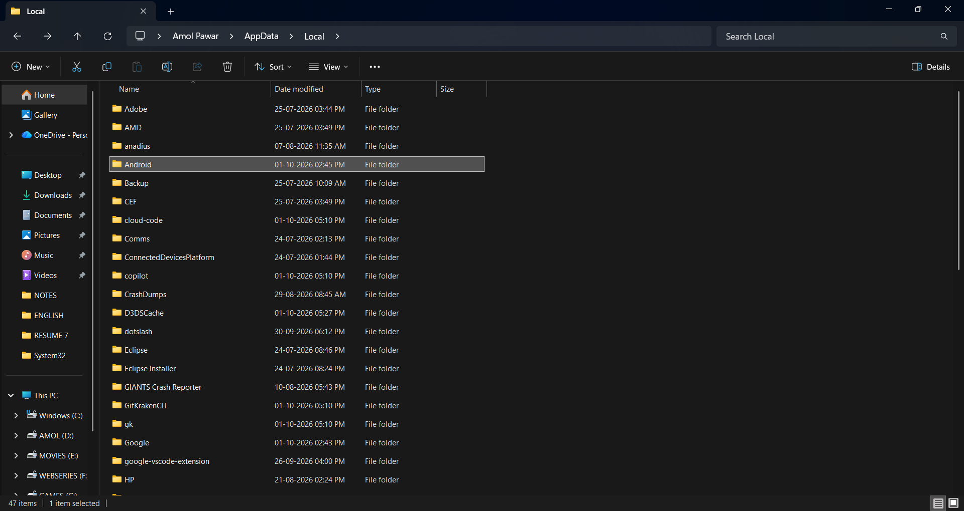
5.Then Go the SDK folder inside the Android.
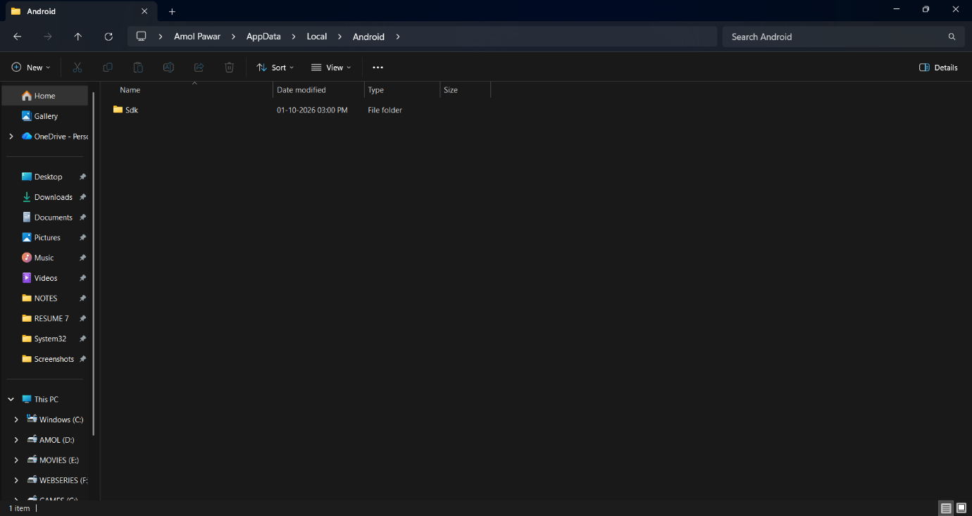
6.Then inside the emulator go the emulator folder
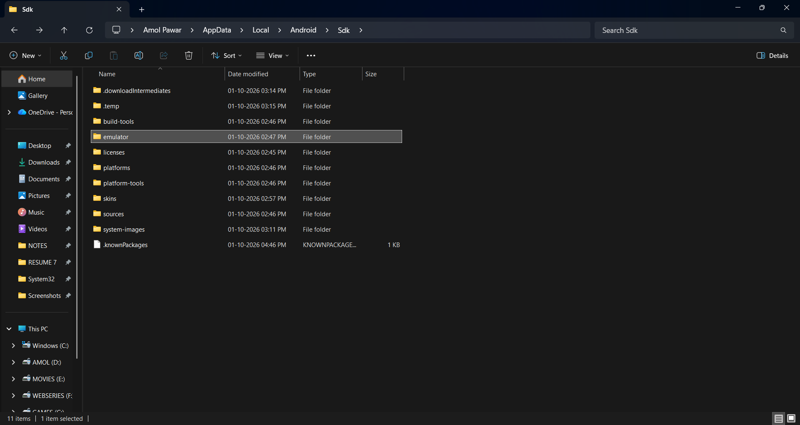
7.Then go to the qemu folder.
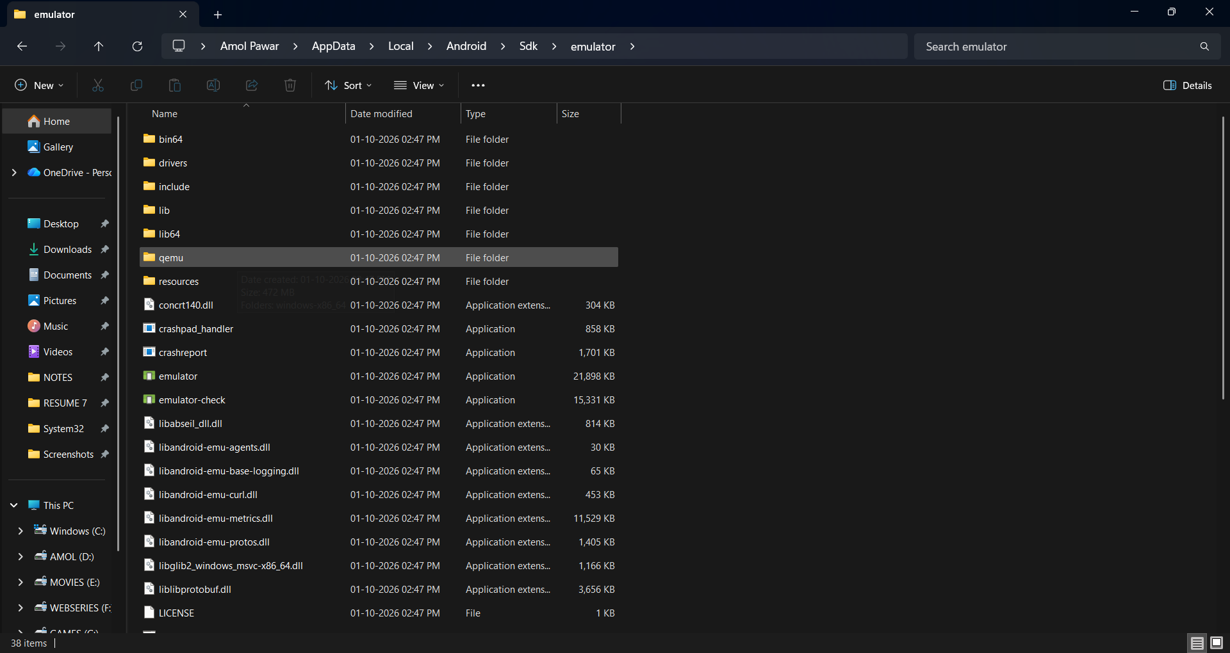
8.Then go to windowsX86_64 folder inside the qemu
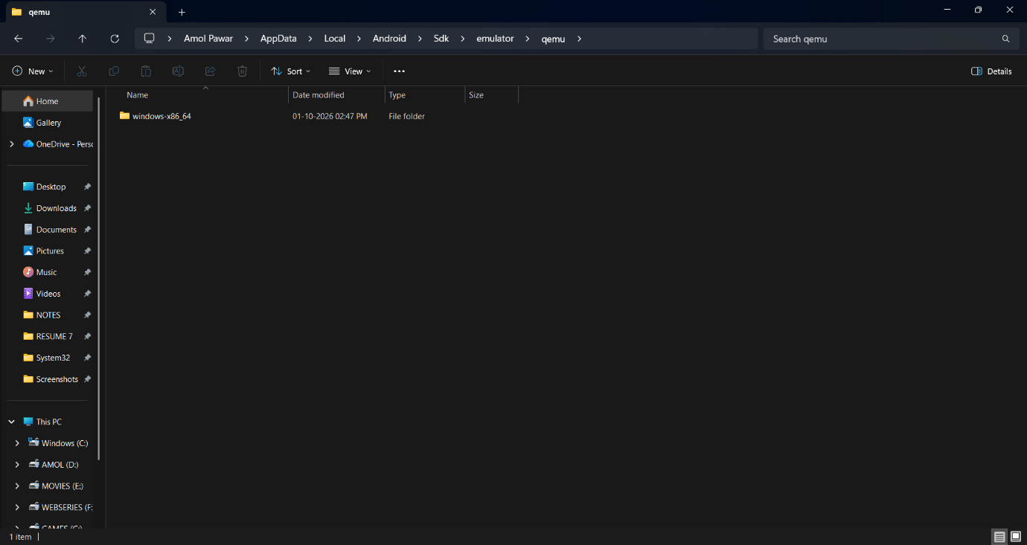

9.Then click on the qemu-system x86_64 exe file and open the Properties option.
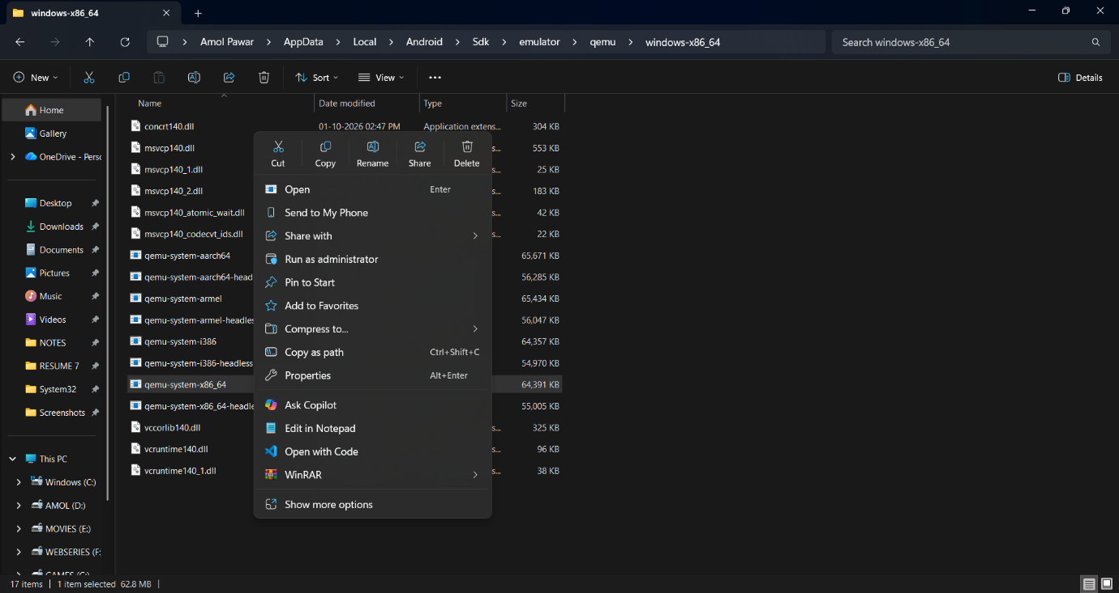

10.Then Click on the Compatibility option after that go to down change high DPI settings.
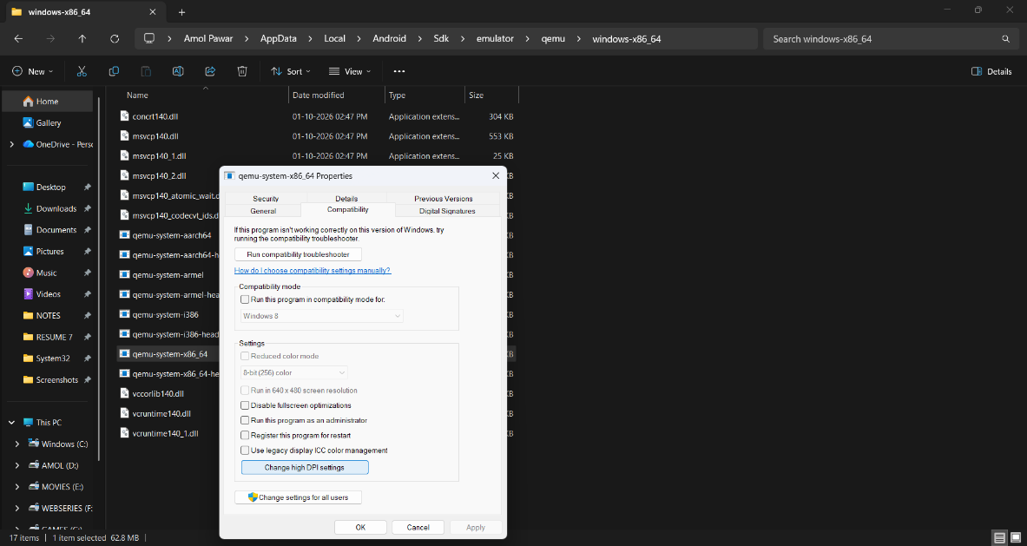
11.Then Click on the Override high DPI scaling behavior and Choose option System.
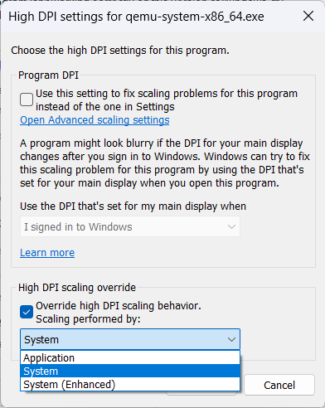

12.Click on Ok button again OK button and Clos window.
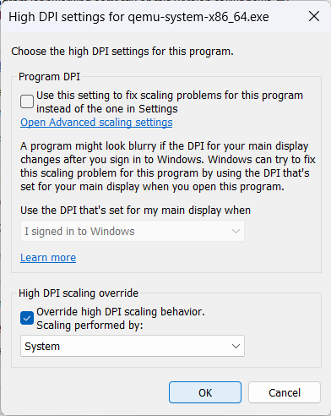

-Now Re-run the ADB device it will appears properly.
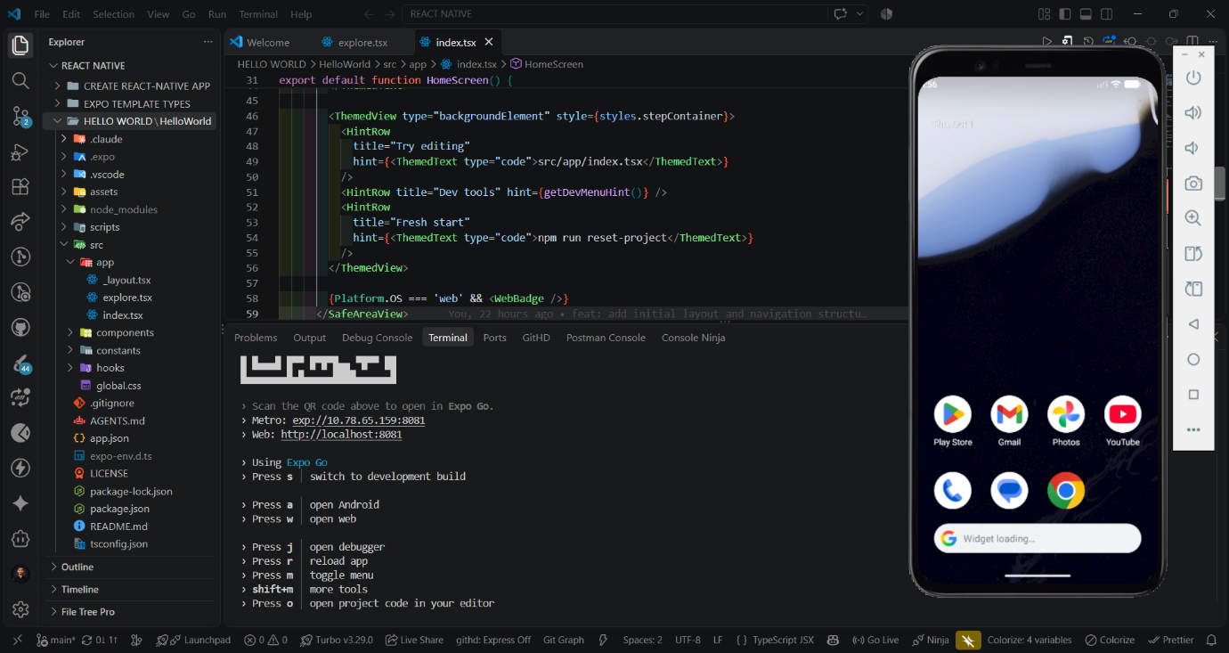

CORE COMPONENTS IN REACT NATIVE

- Core Components are pre-built UI components provided by React Native. They are used to create the basic structure and user interface of a mobile application without writing native Android or iOS code directly.
- They are available directly from the react-native package.
- They provide common UI elements such as containers, text, images, inputs, buttons, lists, and scrolling areas.
- They work across Android and iOS, with platform-specific behavior where required.
-React Native offers a collection of essential pre-built components knows as core-components. Which are readily available for building your native app’s user interface.
1. View
- View is the most basic and commonly used container component in React Native.
- It is similar to <div> in HTML.
- It is used to group, arrange, and style other components.
- It supports layout using Flexbox.
- It can be used for:
  - Layout
  - Grouping components
  - Applying styles
  - Creating sections of the screen
Basic structure:
View
├── Text
├── Text
└── Button

import { View } from 'react-native';

<View>
{/* Components */}
</View>

2. Text
- Text is used to display text content on the screen.
- It is similar to <p>, <span>, or headings in HTML.
- Text styling can be applied using the style prop.
- It is the basic component for showing:
  - Headings
  - Paragraphs
  - Labels
  - Messages
  - Button-like text
- Unlike React.js, normal text should not be placed directly inside View.
Example:
import { Text } from "react-native";

const App = () => {
return <Text>Hello React Native</Text>;
};
With styling:
<Text style={{ fontSize: 24, fontWeight: "bold" }}>
Welcome
</Text>

3. Image
- Image is used to display images in a React Native application.
- It can display:
  - Local images
  - Remote images
- When displaying a remote image, the source normally uses a URI.
- Image dimensions generally need to be specified through styles.
Local image:
import { Image } from "react-native";

<Image source={require("./assets/logo.png")} />
Remote image:
<Image
source={{ uri: "https://example.com/image.jpg" }}
style={{ width: 200, height: 200 }}
/>

4. TextInput
- TextInput is used to accept text input from the user.
- It is commonly used for:
  - Username
  - Email
  - Password
  - Search
  - Forms
  - Messages
Example:
- secureTextEntry hides the entered characters.
import { TextInput } from "react-native";

<TextInput
placeholder="Enter your name"
style={{ borderWidth: 1, padding: 10 }}
/>
Password input:
<TextInput
placeholder="Enter password"
secureTextEntry
/>

5. Button
- Button is a basic pressable button component.
- It performs an action when the user presses it.
- The onPress prop is used to define the action.
Important:
- Button is useful for simple buttons.
- For highly customized buttons, developers commonly use Pressable or TouchableOpacity.
import { Button } from 'react-native';

<Button
title="Click Me"
onPress={() => alert('Button Pressed')}
/>

6. Pressable
- Pressable is used to create components that respond to touch or press interactions.
- It provides more control than the basic Button component.
- It can detect different interaction states such as:
  - Pressed
  - Not pressed
- It can be used to create:
  - Custom buttons
  - Cards
  - Clickable icons
  - Menu items
  - Custom controls

Example:
import { Pressable, Text } from "react-native";

<Pressable onPress={() => console.log("Pressed")}>
<Text>Click Me</Text>
</Pressable>

Press state:
<Pressable
onPress={() => console.log("Pressed")}
>
{({ pressed }) => (
<Text>
{pressed ? "Pressed" : "Press Me"}
</Text>
)}
</Pressable>
- pressed tells us whether the component is currently being pressed.

7. TouchableOpacity
- TouchableOpacity is used to create touchable elements.
- It provides a visual opacity effect when the user presses the component.
- It is commonly used for custom buttons.
import { TouchableOpacity, Text } from 'react-native';

<TouchableOpacity onPress={() => console.log('Pressed')}>
<Text>Submit</Text>
</TouchableOpacity>

-Pressable is the more modern and flexible option for handling press interactions.

8. ScrollView
- ScrollView allows users to scroll through content.
- It can scroll vertically or horizontally.
- It is useful when the amount of content is relatively small.
Example:
import { ScrollView, Text } from 'react-native';

<ScrollView>
<Text>Content 1</Text>
<Text>Content 2</Text>
<Text>Content 3</Text>
</ScrollView>

-By default, ScrollView scrolls vertically.
Horizontal scrolling:
<ScrollView horizontal>
<Text>Item 1</Text>
<Text>Item 2</Text>
<Text>Item 3</Text>
</ScrollView>

Important
- ScrollView renders its children as part of the scrollable content.
- It is suitable for smaller or moderate amounts of content.
For large lists, FlatList is generally more appropriate.

9. FlatList
- FlatList is used to display lists of data efficiently.
- It renders only the items that are currently needed on the screen.
- It is preferred for large or dynamic lists.
- It supports features such as:
  - Efficient rendering
  - Scrolling
  - Item separators
  - Headers
  - Footers
  - Pull-to-refresh
Example:
import { FlatList, Text } from "react-native";

const users = [
{ id: "1", name: "Amol" },
{ id: "2", name: "Rahul" },
{ id: "3", name: "Amit" },
];

<FlatList
data={users}
keyExtractor={(item) => item.id}
renderItem={({ item }) => (
<Text>{item.name}</Text>
)}
/>
Important Props
data
- Contains the list of data.
renderItem
- Defines how each item should be displayed.
keyExtractor
- Provides a unique key for each item.

10. SectionList
- SectionList is used to display grouped lists of data.
- Data is divided into multiple sections.
- Each section can have its own header.
Example:
Fruits
- Apple
- Mango

Vegetables
- Potato
- Tomato
import { SectionList, Text } from 'react-native';

<SectionList
sections={data}
renderItem={({ item }) => <Text>{item}</Text>}
renderSectionHeader={({ section }) => (
<Text>{section.title}</Text>
)}
/>

11. ActivityIndicator
- ActivityIndicator displays a loading indicator.
- It is commonly used while:
  - Fetching API data
  - Loading screens
  - Processing operations
import { ActivityIndicator } from 'react-native';

<ActivityIndicator size="large" />

12. Switch
- Switch provides a toggle control.
- It is generally used for enabling or disabling a setting.
import { Switch } from 'react-native';

<Switch
value={isEnabled}
onValueChange={setIsEnabled}
/>

13. Modal
- Modal displays content above the current screen.
- It is useful for:
  - Dialog boxes
  - Confirmation screens
  - Forms
  - Popup-style content
import { Modal, Text } from 'react-native';

<Modal visible={true}>
<Text>This is a modal</Text>
</Modal>

14. SafeAreaView
- SafeAreaView helps place content inside the safe area of the device screen.
- It helps prevent content from overlapping areas such as:
  - Notches
  - Status bars
  - Rounded screen corners

import { SafeAreaView, Text } from 'react-native';

<SafeAreaView>
<Text>Hello</Text>
</SafeAreaView>

15. StatusBar
- StatusBar is used to control the appearance of the device status bar.
- It can control properties such as the status bar style and background on supported platforms.
import { StatusBar } from 'react-native';

<StatusBar barStyle="dark-content" />

Core Components vs HTML Elements
React Native does not use normal HTML elements such as:
<div>
<p>
<img>
<input>
Instead, it provides mobile-focused components:
React.js / HTML | React Native
<div> | <View>
<p> | <Text>
<img> | <Image>
<input> | <TextInput>
<button> | <Button> / <Pressable>
<ul> / <li> | <FlatList> / <SectionList>

Important Core Components
Component | Main Purpose
View | Container/layout
Text | Display text
Image | Display images
TextInput | User text input
Button | Basic button
Pressable | Custom press interaction
TouchableOpacity | Touchable element with opacity feedback
ScrollView | Scrollable content
FlatList | Efficient list rendering
SectionList | Grouped lists
ActivityIndicator | Loading indicator
Switch | Toggle control
Modal | Overlay/popup content
SafeAreaView | Safe screen-area layout
StatusBar | Status bar control

Core Components Example
-A simple React Native screen can combine multiple core components:
import {
View,
Text,
Image,
TextInput,
Pressable,
ScrollView,
} from "react-native";

const App = () => {
return (
<ScrollView>
<View>
<Image
source={require("./assets/logo.png")}
style={{ width: 100, height: 100 }}
/>

<Text>Welcome to React Native</Text>

<TextInput
placeholder="Enter your name"
/>

<Pressable
onPress={() => console.log("Pressed")}
>
<Text>Submit</Text>
</Pressable>
</View>
</ScrollView>
);
};

export default App;

Here:
ScrollView
↓
View
├── Image
├── Text
├── TextInput
└── Pressable
↓
Text

Core Components and Their Main Purpose
Component | Main Purpose
View | Container and layout
Text | Display text
Image | Display images
TextInput | Accept user input
Button | Simple button
Pressable | Handle press interactions
ScrollView | Scroll content
FlatList | Display efficient lists
SectionList | Display grouped lists
ActivityIndicator | Show loading indicator
Switch | ON/OFF control
Modal | Display content above the current screen
StatusBar | Control status bar appearance
KeyboardAvoidingView | Adjust UI around keyboard
SafeAreaView | Keep content in safe screen areas
RefreshControl | Pull-to-refresh

Key Points to Remember
- Core Components are built-in React Native components.
- They are imported from the react-native package.
- View is mainly used for containers and layouts.
- Text is used to display text.
- Image displays images.
- TextInput accepts user input.
- Button provides a simple button.
- Pressable provides customizable press interactions.
- ScrollView is used for scrollable content.
- FlatList is designed for efficient lists.
- SectionList is used for grouped lists.
- ActivityIndicator displays loading states.
- Switch provides ON/OFF functionality.
- Modal displays content above the current screen.
- KeyboardAvoidingView helps with the on-screen keyboard.
- Core Components form the basic building blocks of React Native UI.

Interview Definition
Core Components in React Native are built-in components provided by React Native that developers use to create mobile user interfaces, such as containers, text, images, inputs, buttons, lists, and scrollable content.

1.View

-View is the most basic and commonly used container component in React Native. It is similar to a <div> in HTML.
-It is used to group, arrange, style, and position other components.
-The view component is a fundamental core component in React Native that serves as a building block for creating user interfaces.
-It functions as a container that supports layout using flexbox, styling touch handling and accessibility controls.
-In web development terms, the view component can be compared to the <div> tag.
-In android and IOS development, we employ a fundamental building block called a “View” For user Interface.
-The view component is typically nested inside other views and can have zero or more children of any type.
-A view is a small rectangular element on the screen that can display text, images or respond to user input.
-In Android Views are written in Kotlin or Java.
-In IOS the views are written in Swift or Objective-C
-At a Runtime, React native generates the corresponding Android and IOS views for these components.
-To use View we always need to import it.
Example:-
Here:
- View → Container
- Text → Displays text
- View can contain other React Native components.

import { View, Text } from 'react-native';

const App = () => {
return (
<View>
<Text>Hello React Native</Text>
</View>
);
};

export default App;

View with Styling
<View style={{ backgroundColor: 'lightblue', padding: 20 }}>
<Text>Hello World</Text>
</View>

-The View creates a container with:
- Background color
- Padding
- Layout
- Width/height
- Border
- Margin
- Flexbox properties
- View is similar to HTML
React Native | HTML
<View> | <div>
<Text> | <p>, <span>
<Image> | <img>
<ScrollView> | Scrollable container

-Example with Multiple Components
<View style={{ padding: 20 }}>
<Text>My Profile</Text>
<Text>Amol Pawar</Text>
<Button title="View Profile" />
</View>

-The View acts as the parent/container for all three components.
Important Point
View does not display text directly.
❌ Incorrect:
<View>Hello World</View>
✅ Correct:
<View>
<Text>Hello World</Text>
</View>

In simple words:
-View is a container component in React Native used to organize, style, and layout other components.

2.Text

- Text is a Core Component in React Native.
- It is used to display text content on the mobile application screen.
- It can be used to display:
  - Normal text
  - Headings
  - Paragraphs
  - Labels
  - Messages
  - Buttons/links text
  - Dynamic data
- In React Native, text content is normally written inside the <Text> component.
-It supports nesting, styling and touch handling.
-Depending on the target platform React Native will translate this component to either a TextView(Android), UITextView{iOS).
Basic Syntax:-
<Text> Hello React Native </Text>

-The Text component is imported from react-native.
import { Text } from "react-native";

Example:

import { Text } from "react-native";

export default function App() {
return (
<Text>
Hello React Native
</Text>
);
}

Text is commonly used inside a View component.
import { View, Text } from "react-native";

export default function App() {
return (
<View>
<Text>Hello React Native</Text>
</View>
);
}

-View is used as a container.
Text is used to display text.

1.For Rendering the text always use <Text> </Text> Component.
-Neither we got warning Text:-
ERROR Text strings must be rendered within a <Text> component.
-So every TextNode must wrapped within the <Text>.
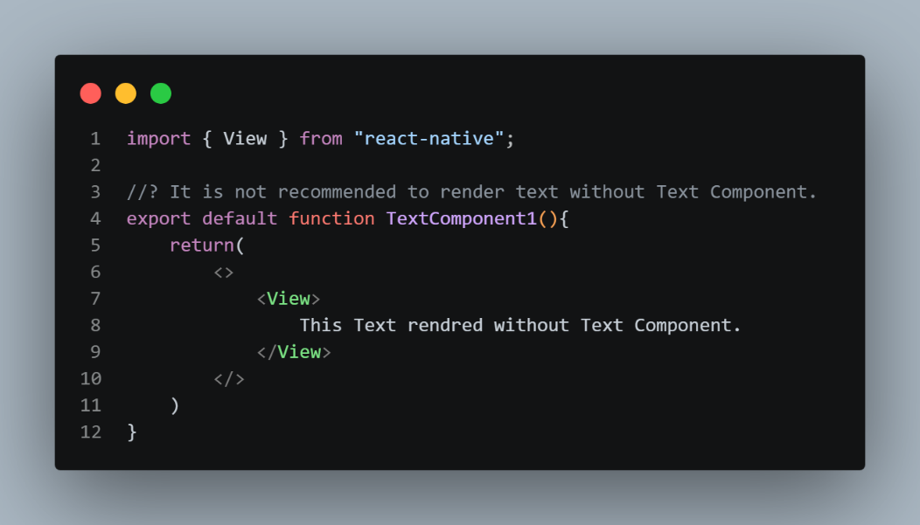
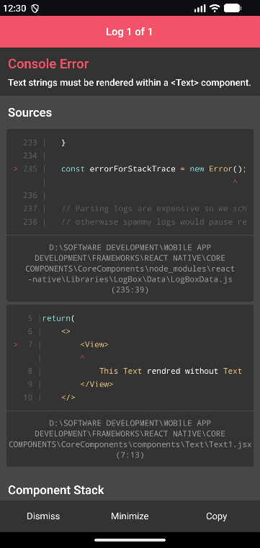

2.Always use the <View> as Parent for it.
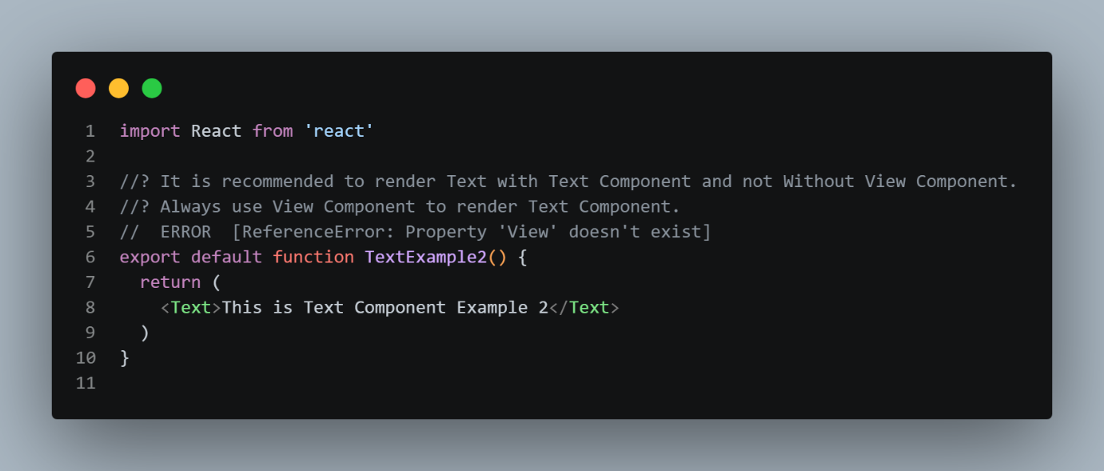
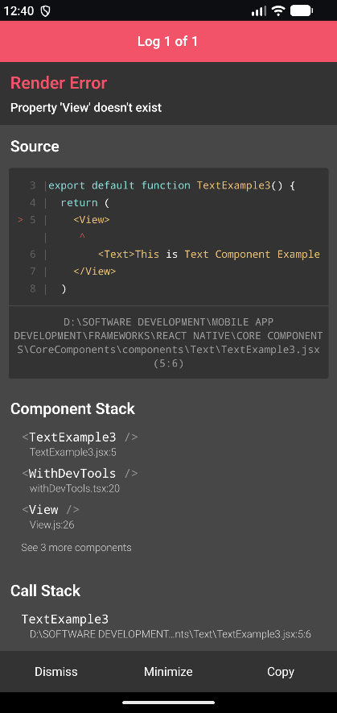

Why Text Component is Required
-React Native does not use HTML elements such as:
<p>Hello</p>
<h1>Hello</h1>
<span>Hello</span>
-Instead, React Native uses:
<Text>Hello</Text>
Text should normally be rendered inside a <Text> component.
Correct
<View>
<Text>Hello React Native</Text>
</View>
Styling Text
-The appearance of text can be controlled using the style prop.
<Text
style={{
color: "blue",
fontSize: 24,
fontWeight: "bold",
}}
>
React Native
</Text>

Common Text Style Properties
- color – Changes text color.
<Text style={{ color: "red" }}>
Red Text
</Text>

- fontSize – Changes the size of text.
<Text style={{ fontSize: 24 }}>
Large Text
</Text>

- fontWeight – Controls the thickness of text.
<Text style={{ fontWeight: "bold" }}>
Bold Text
</Text>

- fontStyle – Makes text normal or italic.
<Text style={{ fontStyle: "italic" }}>
Italic Text
</Text>

- textAlign – Controls horizontal text alignment.
<Text style={{ textAlign: "center" }}>
Center Text
</Text>

- textDecorationLine – Adds underline or line-through.

<Text style={{ textDecorationLine: "underline" }}>
Underline Text
</Text>

- lineHeight – Controls the height of each line.
<Text style={{ lineHeight: 30 }}>
This is a text with
multiple lines.
</Text>

- letterSpacing – Controls the spacing between characters.
<Text style={{ letterSpacing: 2 }}>
React Native
</Text>

- textTransform – Changes the text case.
<Text style={{ textTransform: "uppercase" }}>
react native
</Text>

3.Image

What is <Image> Component?
- <Image> is a Core Component in React Native.
- It is used to display images in a React Native application.
- Images can be loaded from:
  - Local files
  - Remote URLs
  - Static assets

Import <Image>
import { Image } from "react-native";
Example:
import { View, Image } from "react-native";

export default function App() {
return (
<View>
<Image />
</View>
);
}

Always Use <Image> for Rendering Images
- In React Native, an image should be rendered using the <Image> component.
- You cannot directly use an image path or URL as UI content.
- The image source is provided through the source prop.
<Image
source={require("./assets/logo.png")}
style={{
width: 200,
height: 200,
}}
/>

Use <View> as the Parent/Container
- <View> is commonly used as the parent/container for an <Image>.
- It helps organize and position the image within the screen.
Example:
import { View, Image } from "react-native";

export default function App() {
return (
<View>
<Image
source={require("./assets/logo.png")}
style={{
width: 200,
height: 200,
}}
/>
</View>
);
}

source Prop

-The source prop specifies which image should be displayed.
-There are two common ways to provide an image:
Local Image
source={require("./assets/logo.png")}
Remote Image
source={{
uri: "https://example.com/logo.png",
}}

Display a Local Image
Suppose your project structure is:
HelloWorld
│
├── assets
│ └── logo.png
│
├── App.js
├── package.json
└── ...

Use:
import { View, Image } from "react-native";
export default function App() {
return (
<View>
<Image
source={require("./assets/logo.png")}
style={{
width: 200,
height: 200,
}}
/>
</View>
);
}

require()
require("./assets/logo.png")
- require() is used to reference a local/static image.
- The path must point to the actual image file.

7. Display a Remote Image
You can display an image from an internet URL using uri.
<Image
source={{
uri: "https://example.com/image.jpg",
}}
style={{
width: 200,
height: 200,
}}
/>

Important
Remote images use:
source={{ uri: "IMAGE_URL" }}

Local Image vs Remote Image
Type | Syntax
Local Image | require("./assets/logo.png")
Remote Image | { uri: "https://..." }

Always Specify Image Dimensions
- An <Image> should generally have a defined width and height.
- These dimensions determine how much space the image occupies.
<Image
source={require("./assets/logo.png")}
style={{
width: 200,
height: 200,
}}
/>

resizeMode
resizeMode controls how the image fits inside its available area.
Common values:
- cover
- contain
- stretch
- repeat
- center
Example
<Image
source={require("./assets/logo.png")}
style={{
width: 300,
height: 200,
}}
resizeMode="contain"
/>

1. resizeMode="cover"
- Image covers the complete area.
- The image may be cropped.
<Image
source={require("./assets/logo.png")}
style={{
width: 300,
height: 200,
}}
resizeMode="cover"
/>

2. resizeMode="contain"
- The complete image remains visible.
- Empty space may appear around the image.
<Image
source={require("./assets/logo.png")}
style={{
width: 300,
height: 200,
}}
resizeMode="contain"
/>

3. resizeMode="stretch"
- Image stretches to fill the specified dimensions.
- The image can become distorted.
<Image
source={require("./assets/logo.png")}
style={{
width: 300,
height: 200,
}}
resizeMode="stretch"
/>

4. resizeMode="center"
- Image is displayed in the center of the available area.

<Image
source={require("./assets/logo.png")}
style={{
width: 300,
height: 200,
}}
resizeMode="center"
/>

5. resizeMode="repeat"
- Image repeats to fill the available area.
- Useful for patterns and textures.
<Image
source={require("./assets/pattern.png")}
style={{
width: 300,
height: 300,
}}
resizeMode="repeat"
/>

6. Styling an Image
You can use the style prop:
<Image
source={require("./assets/logo.png")}
style={{
width: 200,
height: 200,
borderRadius: 20,
}}
/>
Common image styles:
- width
- height
- borderRadius
- borderWidth
- borderColor
- opacity
- margin
- padding

7. Circular Image
Use borderRadius to create a circular image.
<Image
source={require("./assets/profile.png")}
style={{
width: 150,
height: 150,
borderRadius: 75,
}}
/>
Formula
-For a square image:
borderRadius = width / 2
Example:
width = 150
height = 150
radius = 75

8. Image Border
<Image
source={require("./assets/logo.png")}
style={{
width: 200,
height: 200,
borderWidth: 2,
borderColor: "black",
}}
/>

9. Image Opacity
The opacity property controls image transparency.
<Image
source={require("./assets/logo.png")}
style={{
width: 200,
height: 200,
opacity: 0.5,
}}
/>

<Image> Does NOT Require <View> as Parent
- <Image> can be rendered directly without a <View>.
- <View> is not mandatory for rendering an image.
- A component can return <Image> directly.
Example
import { Image } from "react-native";
export default function ImageExample1() {
return (
<Image
source={require("../../assets/splash-icon.png")}
style={{
width: 100,
height: 100,
}}
/>
);
}

This is completely valid.
Structure
Image
There is no <View> involved.

Why Does <Image> Work Without <View>?
- React Native components do not automatically require <View> as their parent.
- <Image> is itself a valid UI component.
- Therefore, it can be returned directly from a component.
Example:
export default function App() {
return (
<Image
source={require("../../assets/splash-icon.png")}
style={{
width: 100,
height: 100,
}}
/>
);
}

The component hierarchy is simply:
App
└── Image

5. When Should We Use <View>?
Use <View> when you need a container for the image.
For example, when you want to:
- Group multiple components
- Control layout
- Apply container styles
- Position components
- Arrange multiple images/components
Example

import { View, Image, Text } from "react-native";

export default function App() {
return (
<View>
<Image
source={require("../../assets/splash-icon.png")}
style={{
width: 100,
height: 100,
}}
/>

<Text>React Native Image</Text>
</View>
);
}

Structure:
View
├── Image
└── Text
Here, <View> is useful because it acts as the container.

<Image> with Multiple Components
A <View> is useful when multiple elements need to be grouped together.
<View>
<Image
source={require("../../assets/splash-icon.png")}
style={{
width: 100,
height: 100,
}}
/>

<Text>Logo</Text>

<Button title="Continue" />
</View>
Structure:
View
├── Image
├── Text
└── Button

Using Fragment Instead of <View>
You can also use a React Fragment:
<>
<Image
source={require("../../assets/splash-icon.png")}
style={{
width: 100,
height: 100,
}}
/>

<Text>Logo</Text>
</>
The Fragment:
<>
...
</>
is different from:
<View>
...
</View>
Fragment
- Groups React elements.
- Does not create a native UI container.
- Does not provide layout styling like View.
View
- Creates a React Native UI container.
- Can be used for layout and styling.
- Supports properties such as flex, padding, margin, backgroundColor, etc.

Fragment with Only One <Image>
You can write:
<>
<Image
source={require("../../assets/splash-icon.png")}
style={{
width: 100,
height: 100,
}}
/>
</>
-But when there is only one component, the Fragment is unnecessary.
You can simply write:
<Image
source={require("../../assets/splash-icon.png")}
style={{
width: 100,
height: 100,
}}
/>
This is cleaner.

Important Rule About <View> and <Image>
❌ Incorrect Rule
Always use <View> as the parent of <Image>.
This is not required.
✅ Correct Rule
<Image> can be rendered directly without a <View>. Use <View> when a container is required for layout, grouping, positioning, or styling.

4.ImageBackground

- ImageBackground is a React Native component used to display an image as a background behind other components.
- It works similarly to a background image in web development.
- You can place components such as Text, View, Button, etc. inside ImageBackground.
1. Import ImageBackground
import { ImageBackground } from "react-native";
2. Basic Syntax
<ImageBackground
source={require("./assets/background.jpg")}
style={{ width: 400, height: 300 }}
>
<Text>Hello World</Text>
</ImageBackground>
Explanation
- source → specifies the background image.
- style → specifies the size and styling of the background.
- Children → components displayed on top of the image.

3. Local Image
For a local image, use require().
<ImageBackground
source={require("./assets/background.jpg")}
style={{ width: 400, height: 300 }}
>
<Text>Welcome</Text>
</ImageBackground>
Important
The path must correctly point to the image file.
require("./assets/background.jpg")

4. Remote Image
For an image from the internet, use the uri property.
<ImageBackground
source={{
uri: "https://example.com/background.jpg",
}}
style={{
width: 400,
height: 300,
}}
>
<Text>Remote Background</Text>
</ImageBackground>
Syntax
source={{
uri: "IMAGE_URL"
}}

5. Text Over Background Image
One of the most common uses of ImageBackground is placing text over an image.
<ImageBackground
source={require("./assets/background.jpg")}
style={{
width: 400,
height: 300,
}}
>
<Text
style={{
color: "white",
fontSize: 24,
}}
>
Mountain View
</Text>
</ImageBackground>
The Text appears above the background image.

6. Using View Inside ImageBackground
View can be used to create a layout over the background.
<ImageBackground
source={require("./assets/background.jpg")}
style={{
width: 400,
height: 300,
}}
>
<View>
<Text>Welcome</Text>
<Text>Explore Nature</Text>
</View>
</ImageBackground>
View is useful when you need to group and arrange multiple components.

7. ImageBackground with resizeMode
resizeMode controls how the background image fits inside its dimensions.
<ImageBackground
source={require("./assets/background.jpg")}
style={{
width: 400,
height: 300,
}}
resizeMode="cover"
>
<Text>Background Content</Text>
</ImageBackground>
Common resizeMode values
- cover
  - Fills the entire area.
  - May crop part of the image.
  - Commonly used for backgrounds.
- contain
  - Displays the complete image.
  - May leave empty space.
- stretch
  - Stretches the image to fill the area.
  - Can distort the image.
- center
  - Places the image in the center.
- repeat
  - Repeats the image to fill the area.
Most common choice
resizeMode="cover"

8. ImageBackground with Full Screen
ImageBackground can be used as a full-screen background.
import { ImageBackground, Text } from "react-native";

export default function App() {
return (
<ImageBackground
source={require("./assets/background.jpg")}
style={{
flex: 1,
}}
resizeMode="cover"
>
<Text
style={{
color: "white",
fontSize: 30,
}}
>
Welcome
</Text>
</ImageBackground>
);
}
flex: 1
style={{ flex: 1 }}
makes the ImageBackground occupy the available screen space.

9. Center Content Over Image
<ImageBackground
source={require("./assets/background.jpg")}
style={{
flex: 1,
justifyContent: "center",
alignItems: "center",
}}
resizeMode="cover"
>
<Text
style={{
color: "white",
fontSize: 30,
}}
>
Welcome
</Text>
</ImageBackground>
Important properties
justifyContent: "center"
- Centers content vertically.
alignItems: "center"
- Centers content horizontally.

10. Adding Overlay
Sometimes text is difficult to read directly on an image.
You can add a semi-transparent overlay using View.
<ImageBackground
source={require("./assets/background.jpg")}
style={{
flex: 1,
}}
>
<View
style={{
flex: 1,
backgroundColor: "rgba(0, 0, 0, 0.4)",
justifyContent: "center",
alignItems: "center",
}}
>
<Text
style={{
color: "white",
fontSize: 30,
}}
>
Welcome
</Text>
</View>
</ImageBackground>
rgba()
rgba(0, 0, 0, 0.4)
means:
- 0 → Red
- 0 → Green
- 0 → Blue
- 0.4 → 40% opacity
This creates a dark transparent layer over the image.

11. Image vs ImageBackground
Image | ImageBackground
Displays an image | Displays an image as a background
Normally used for standalone images | Used when content needs to appear over an image
Does not normally contain child UI content | Can contain child components
Example: profile photo | Example: hero/banner section
Image
<Image
source={require("./assets/photo.jpg")}
style={{
width: 200,
height: 200,
}}
/>
ImageBackground
<ImageBackground
source={require("./assets/background.jpg")}
style={{
width: 400,
height: 300,
}}
>
<Text>Text over image</Text>
</ImageBackground>

12. Important Point — View is Not Mandatory
Just like Image, ImageBackground does not require a separate View parent.
This is valid:
<ImageBackground
source={require("./assets/background.jpg")}
style={{
width: 400,
height: 300,
}}
>
<Text>Hello</Text>
</ImageBackground>
You can use View inside ImageBackground when you need it for layout.

13. Common Use Cases
ImageBackground is commonly used for:
- Login screen backgrounds
- Signup screen backgrounds
- Home screen banners
- Hero sections
- Profile headers
- Promotional cards
- Landing pages
- Travel cards
- Product banners
- Full-screen image backgrounds

14. Important Notes
- ImageBackground is imported from react-native.
- Use source to provide the image.
- Use require() for local images.
- Use { uri: "..." } for remote images.
- Give the component an appropriate width and height, or use flex: 1.
- resizeMode="cover" is commonly used for backgrounds.
- Child components are rendered on top of the image.
- View is not mandatory as a parent.
- Use View when you need additional layout or grouping.
- Use an overlay when text needs better readability.

5.ScrollView

2.Text

